CASUAL, DRESS-UP AND SPECIAL OCCASION
PURPOSE: To look sexy, cool, nice, CLASSIC and appropriate. And to have nice clothes even if you are big (5 XL). All at the lowest costs. Recommended # of outfits: 2 sweaters, 2 dress-shirt outfits, and 3-big print shirts; overlap the pants. Note: You would be able to find the cheapest clothes on www.Temu.com; and they do have so much plus sizes.

MEANINGS OF ITEMS
The “No Boundaries” sweater means there are no boundaries that God can overcome.
The Casual Dress Shirts mean we can be sexy, and promote sexiness in private environments.
The Big Print Tennis/Golf club cool represent that we are Spiritually cool.

The Dickie Pants and Dickie/Dickie like Jackets mean we mean serve, are Spiritual service men.

Black Dress Boots means Sexy Hard Worker.

The Beads represent our Pearls of (precious) Wisdom.

Miami means we love our beautiful: Florida beaches and women.

NY means we do not believe in Racism and are Communication Outspoken (NY, NY USA is known for freedom of.

Mexico means we are for Mexicans too.
CASUAL SHIRTS
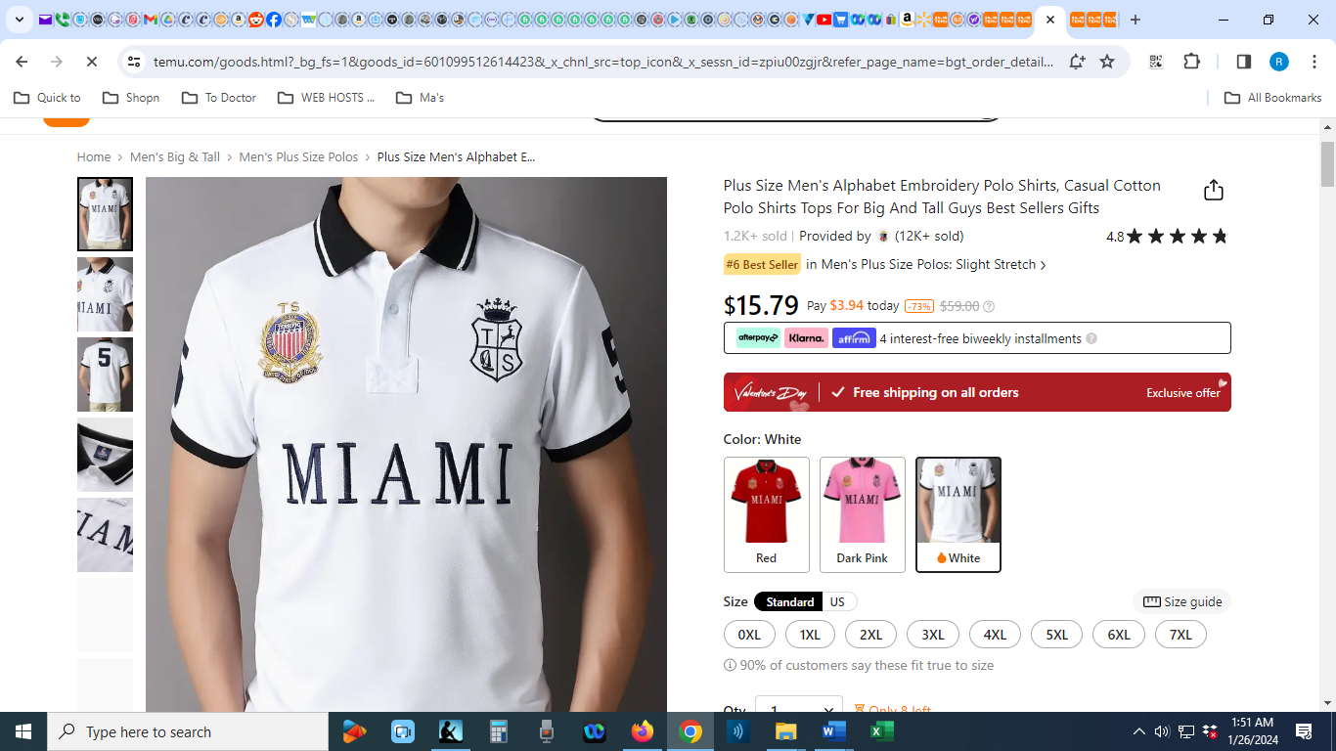
Link

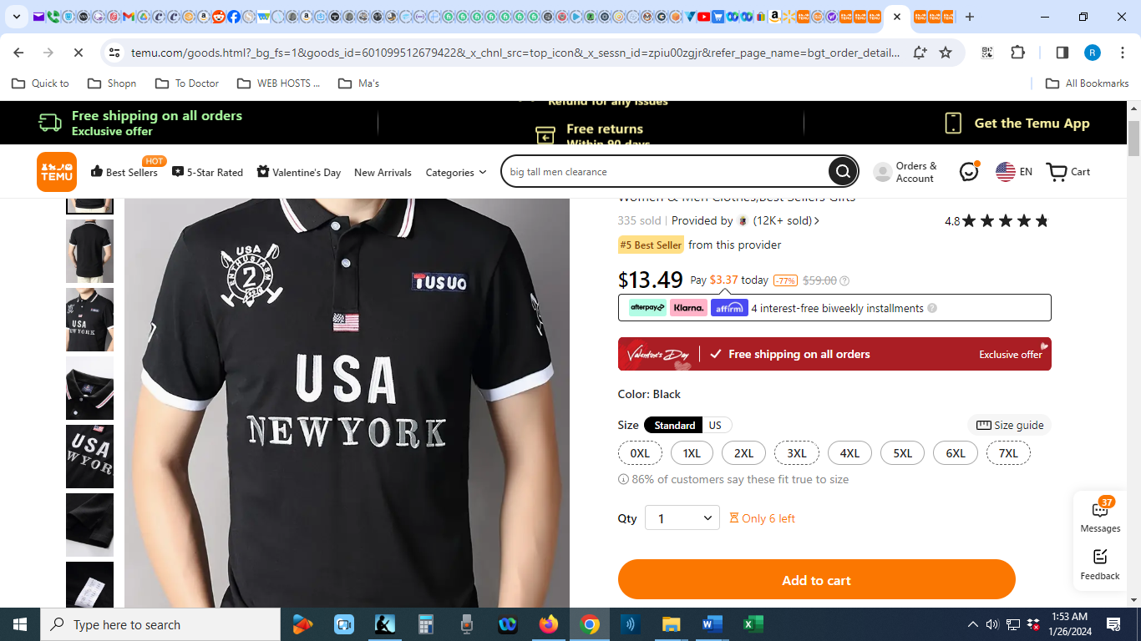
Link

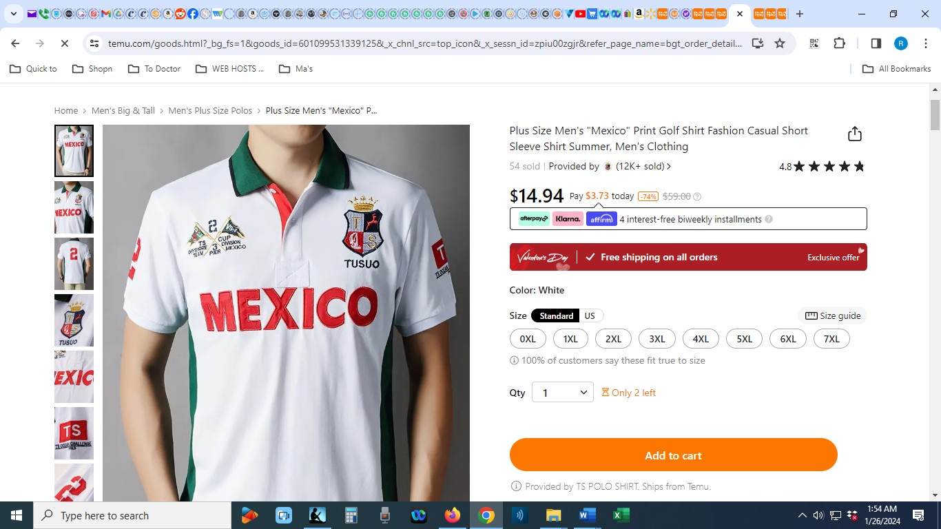
Link

CASUAL PANTS
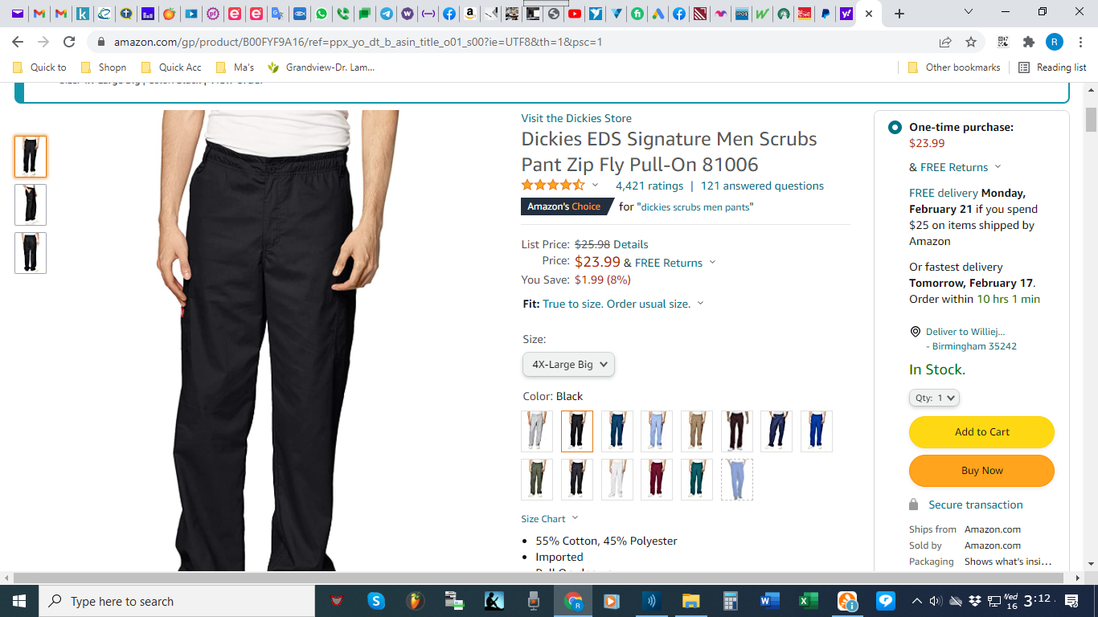
Link
CASUAL SHOES
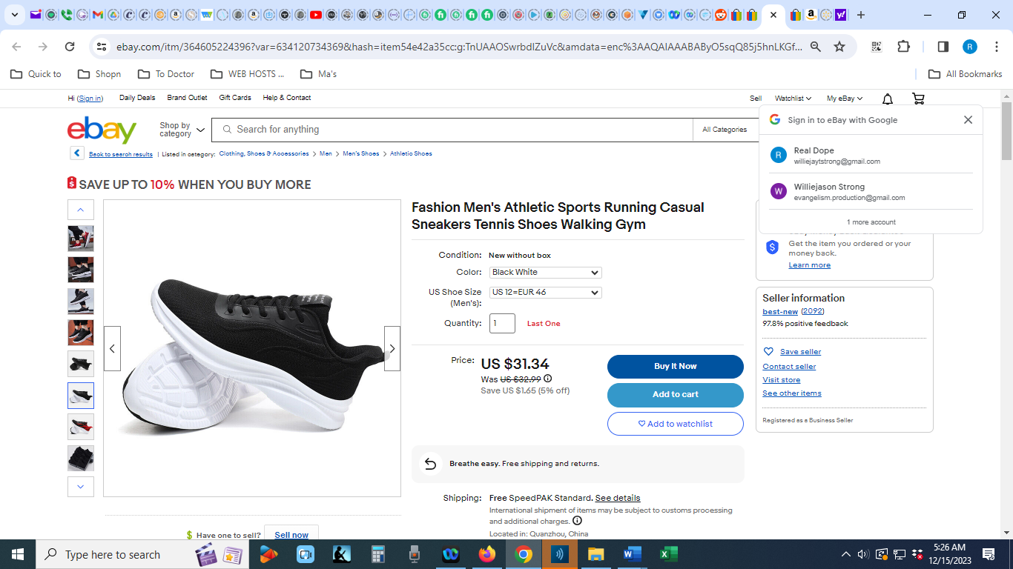
Link

CASUAL DRESS SHIRTS
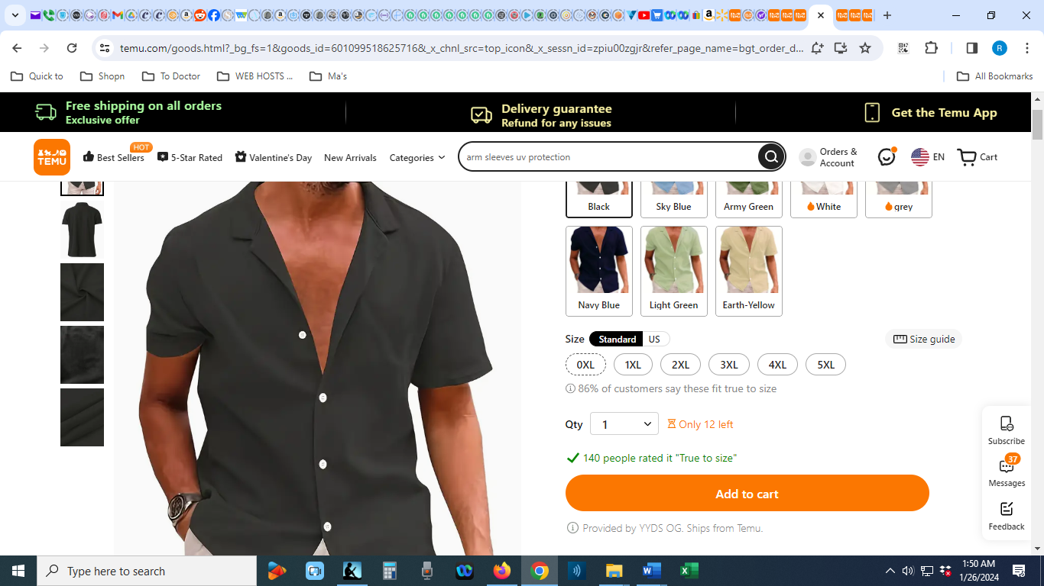
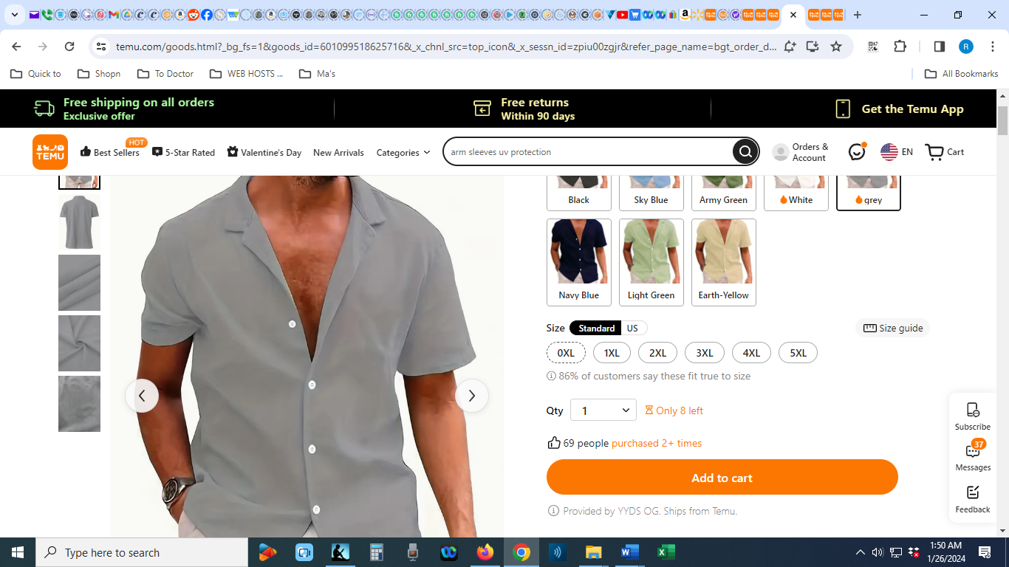
Link

DRESS BOOTS
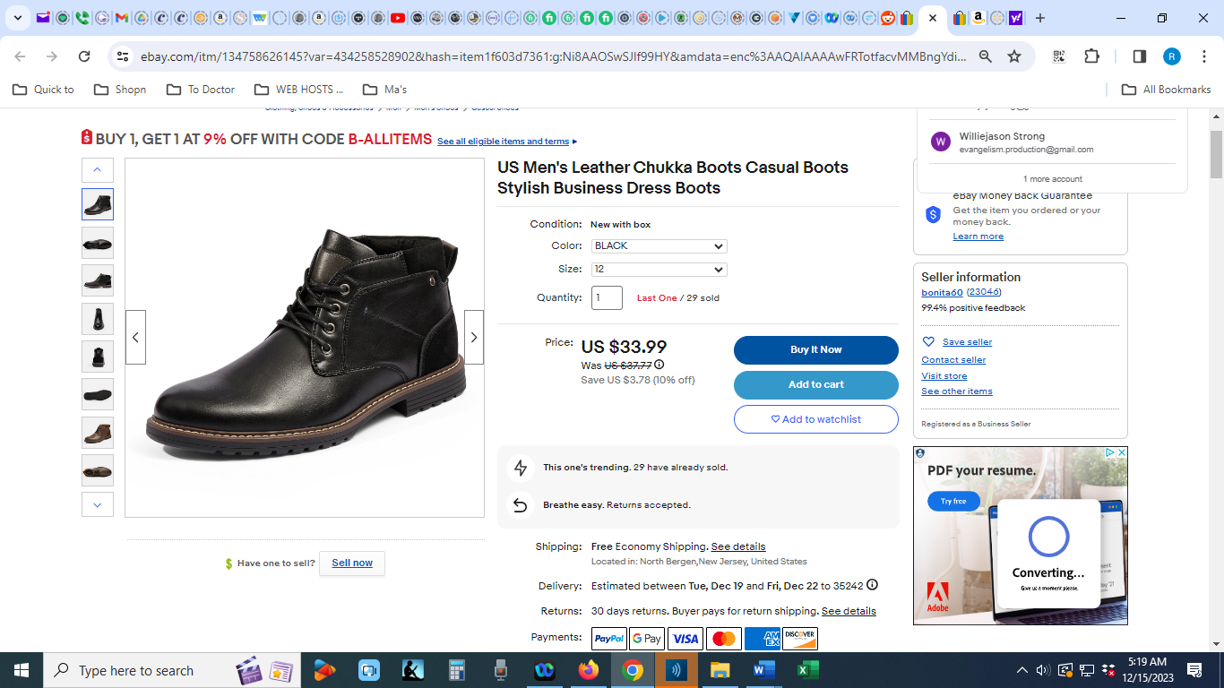
Link

DRESS ASSESORIES
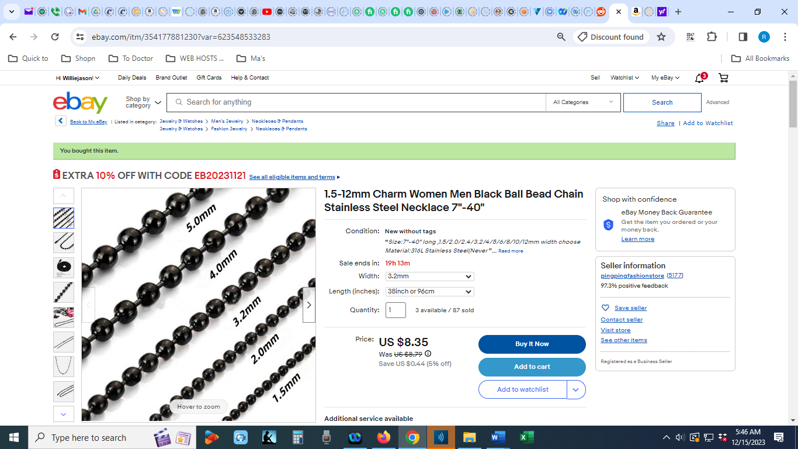
Link

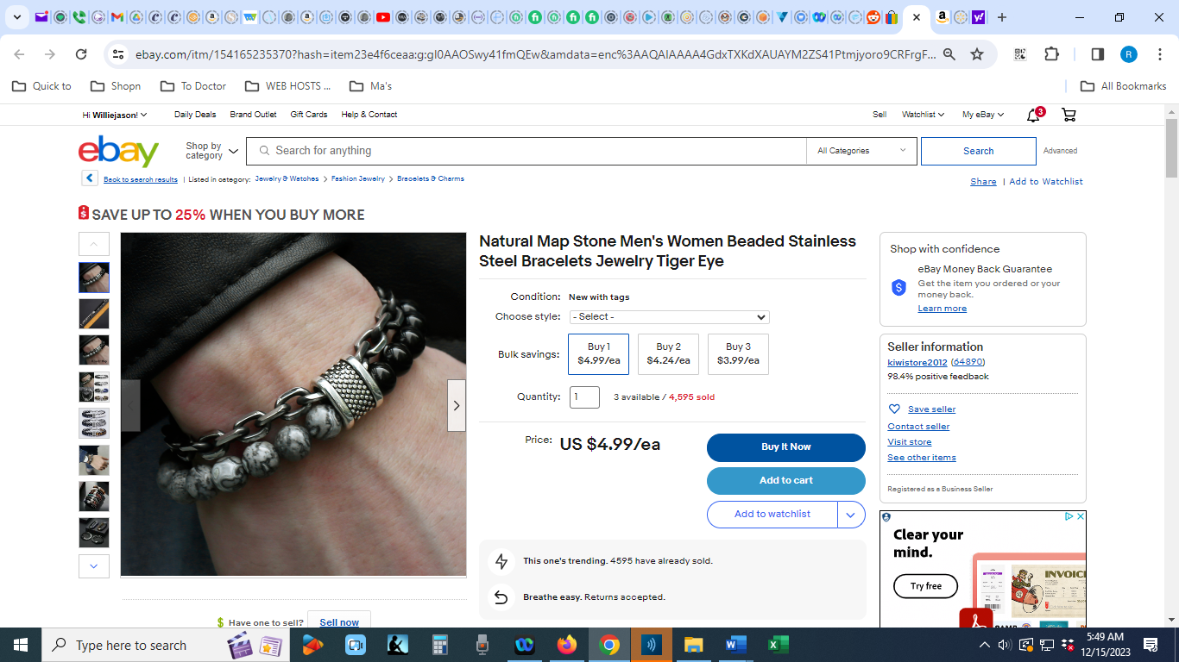
Link
SWEATERS
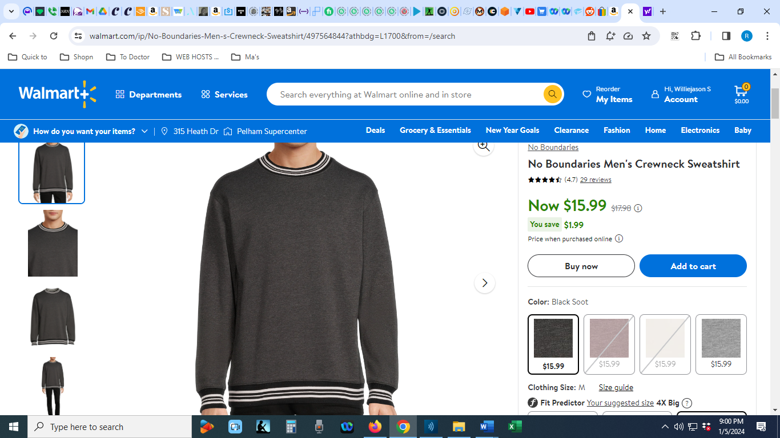
Link

JACKETS
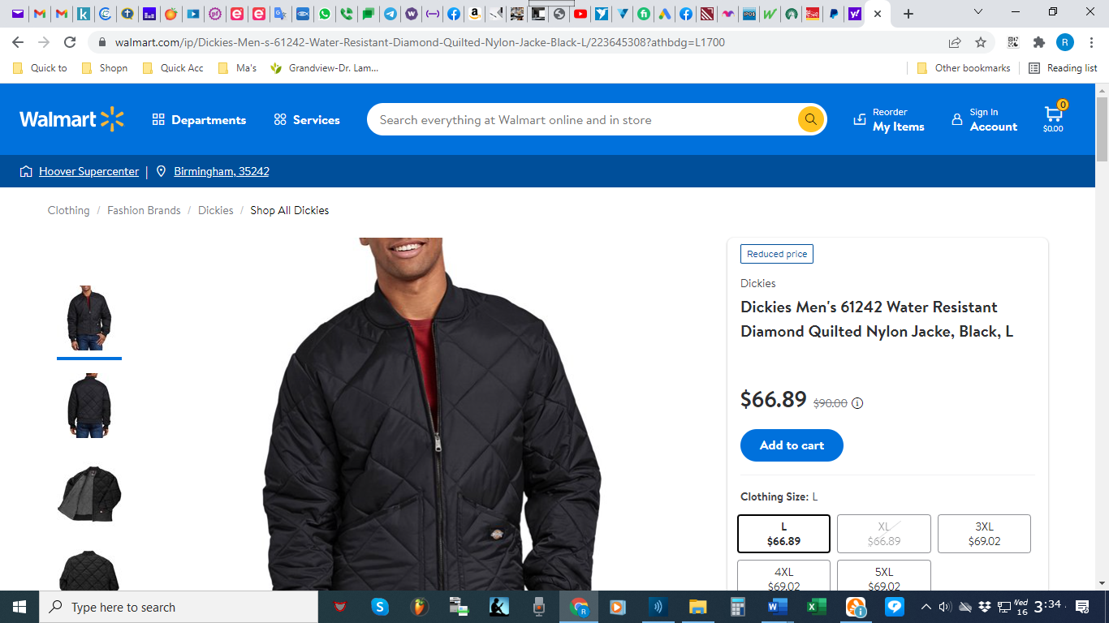
Link

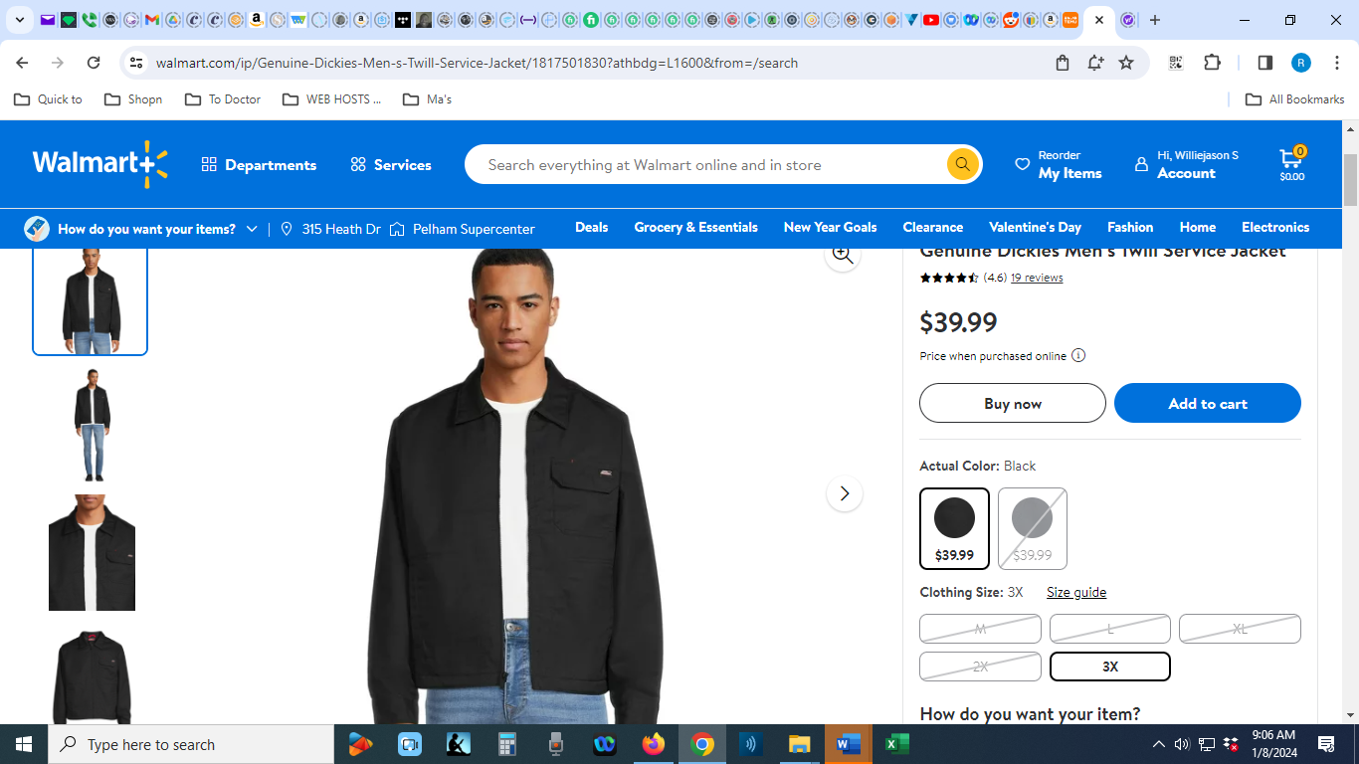
Link

