UNDERGARMENTS-REGULAR, AND SEXY
PURPOSE: To look sexy, cool, nice, CLASSIC and appropriate. And to have nice clothes even if you are big (5 XL). All at the lowest costs. Recommended # of outfits: 2 pajama sets, lots of non-compression undergarments. Personally I keep: 2 shopping bags of t-shirts, 1 shopping bag of briefs and 1 shopping bag of socks. Note: You would be able to find the cheapest clothes on www.Temu.com; and they do have so much plus sizes.

MEANINGS OF ITEMS
We have the “power” of Green Lantern;
Cool looking Lime Green shirts mean we have God’s SPECIAL energy.

REGULAR
Link
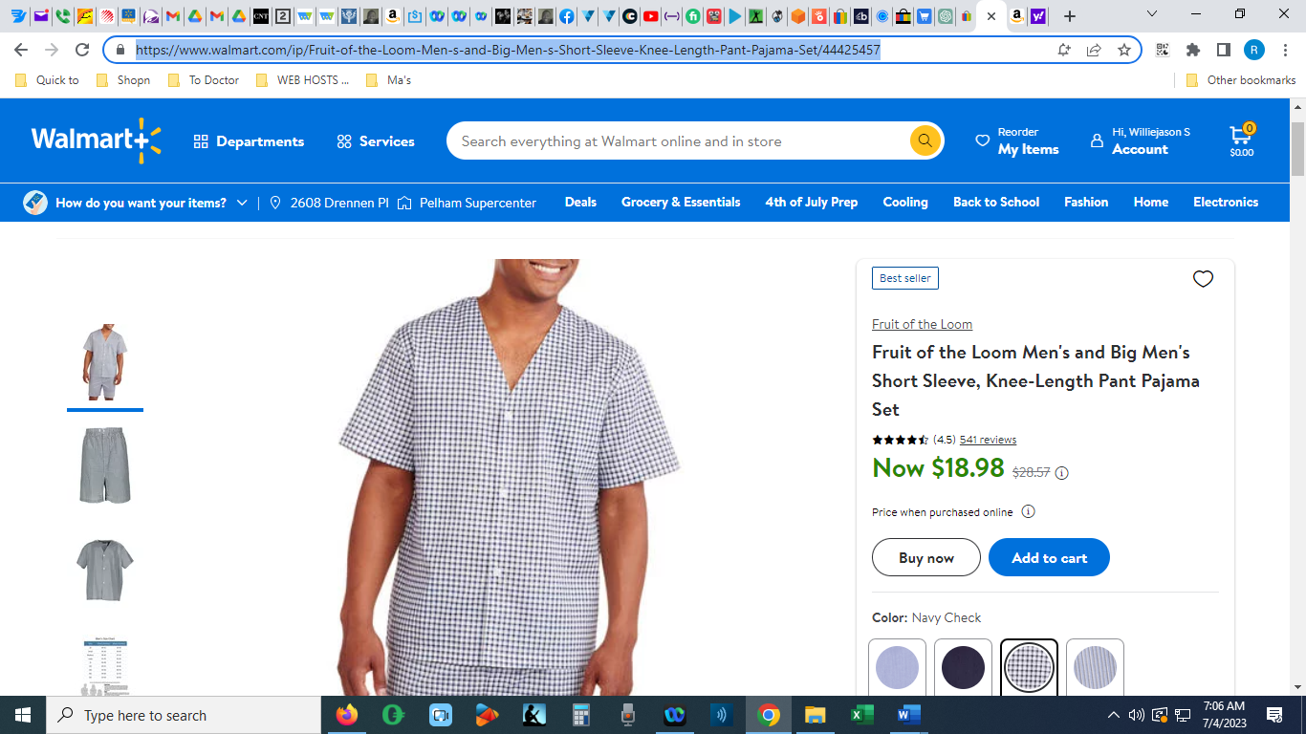

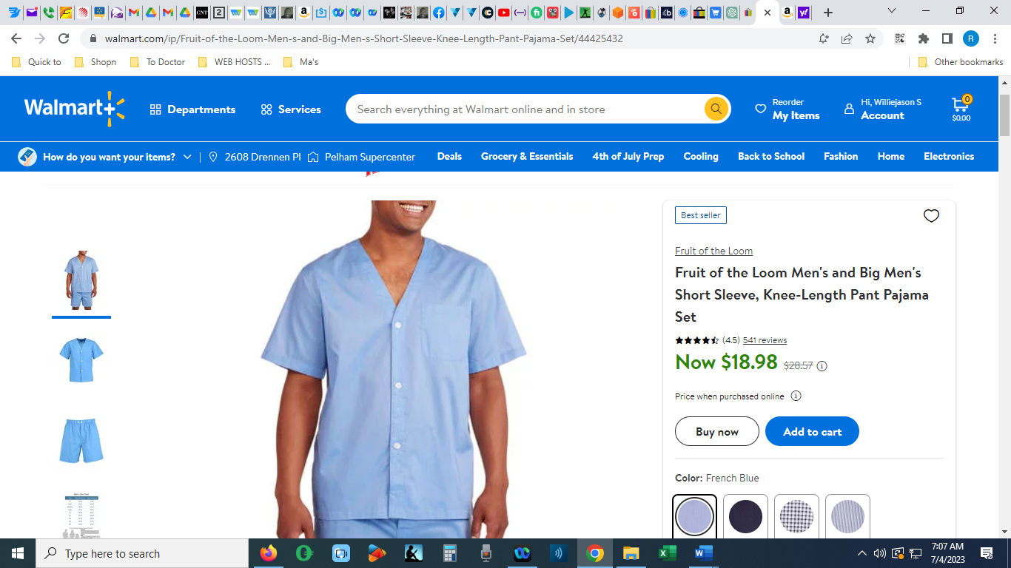
Link
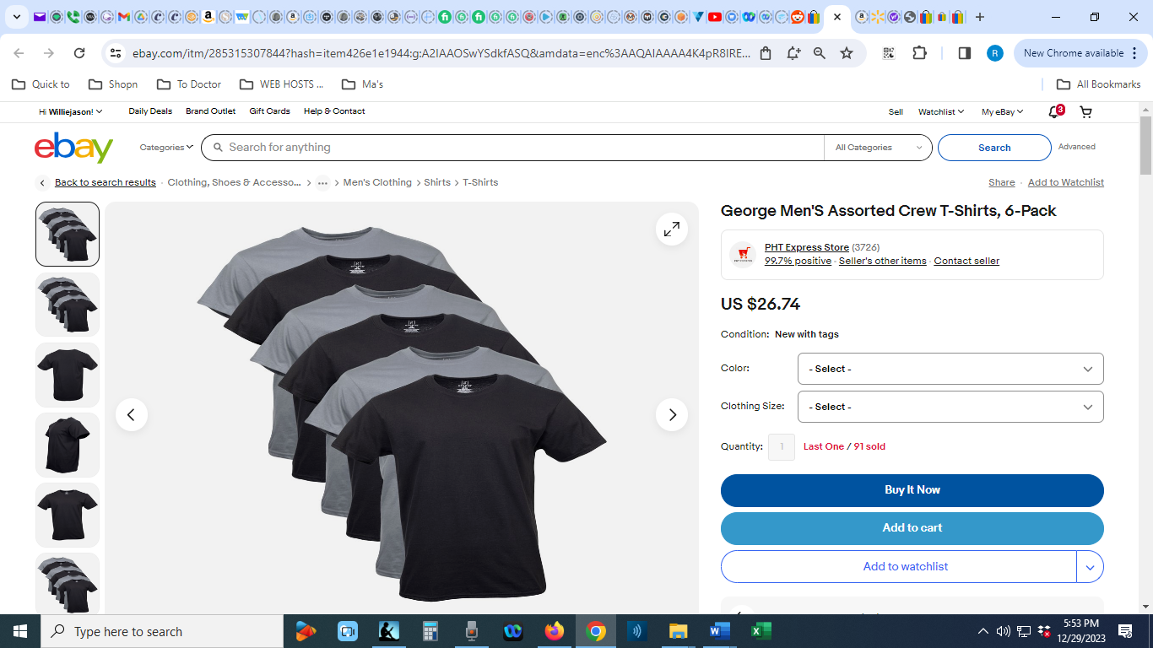

Link
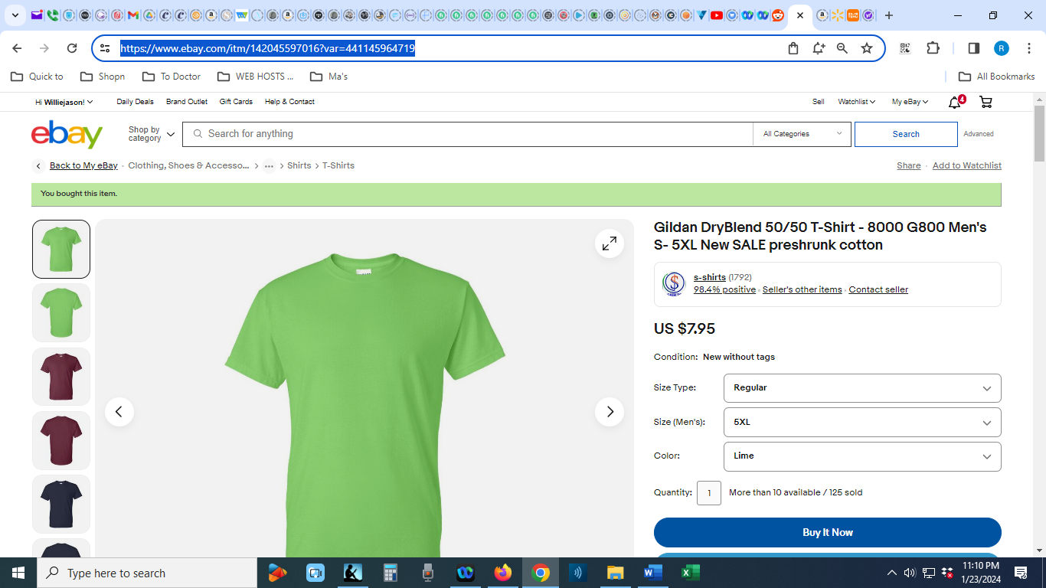
Link
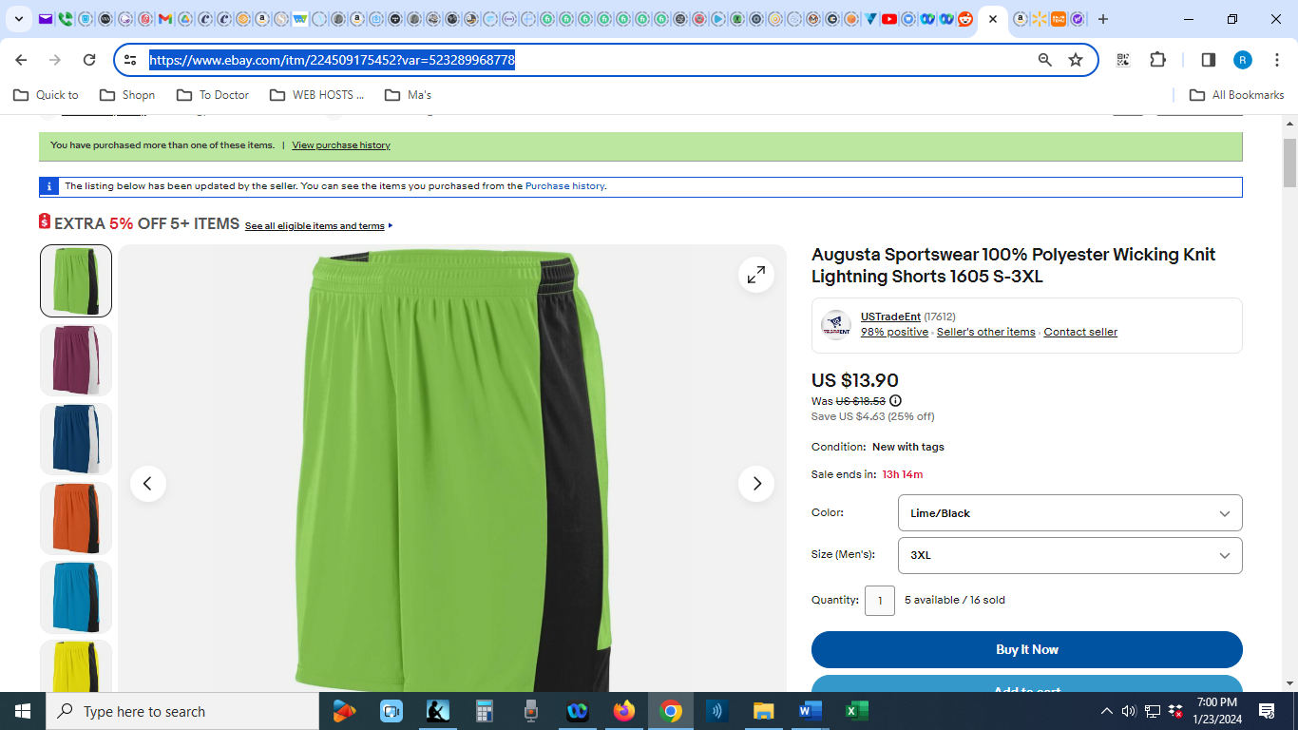
Link
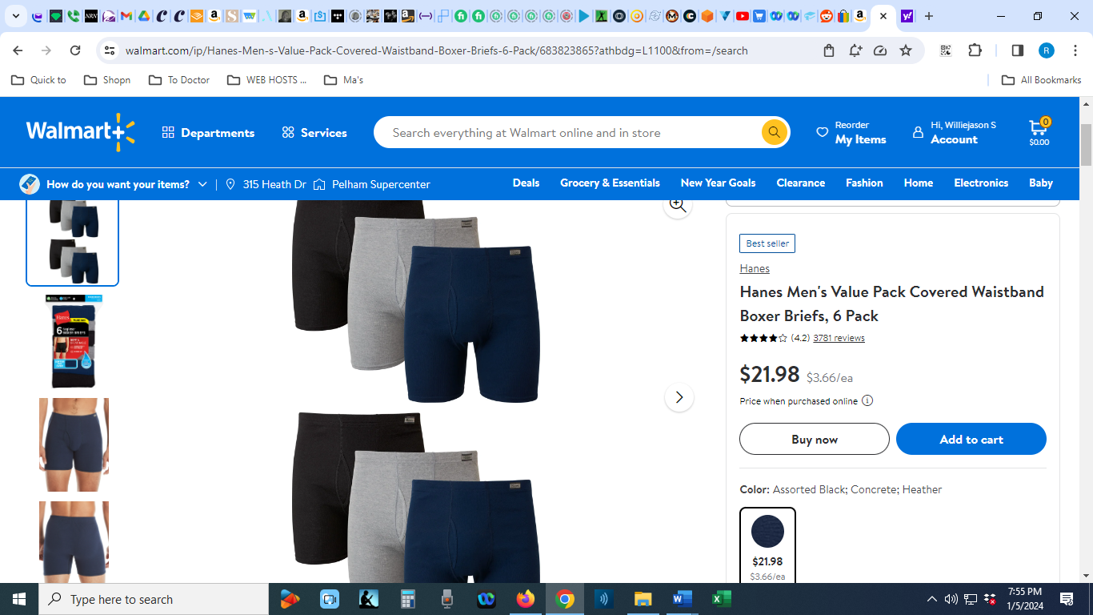

Link
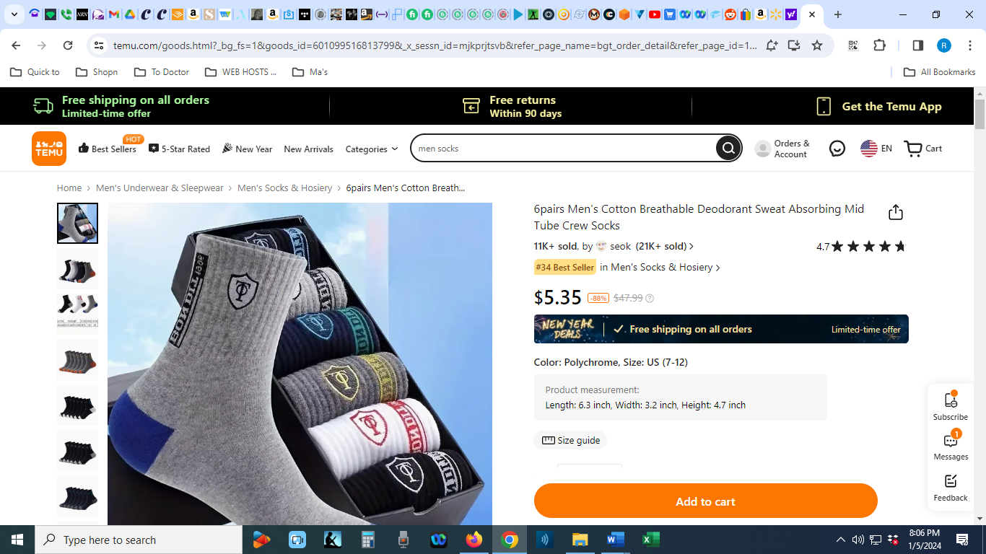
SEXY
Link
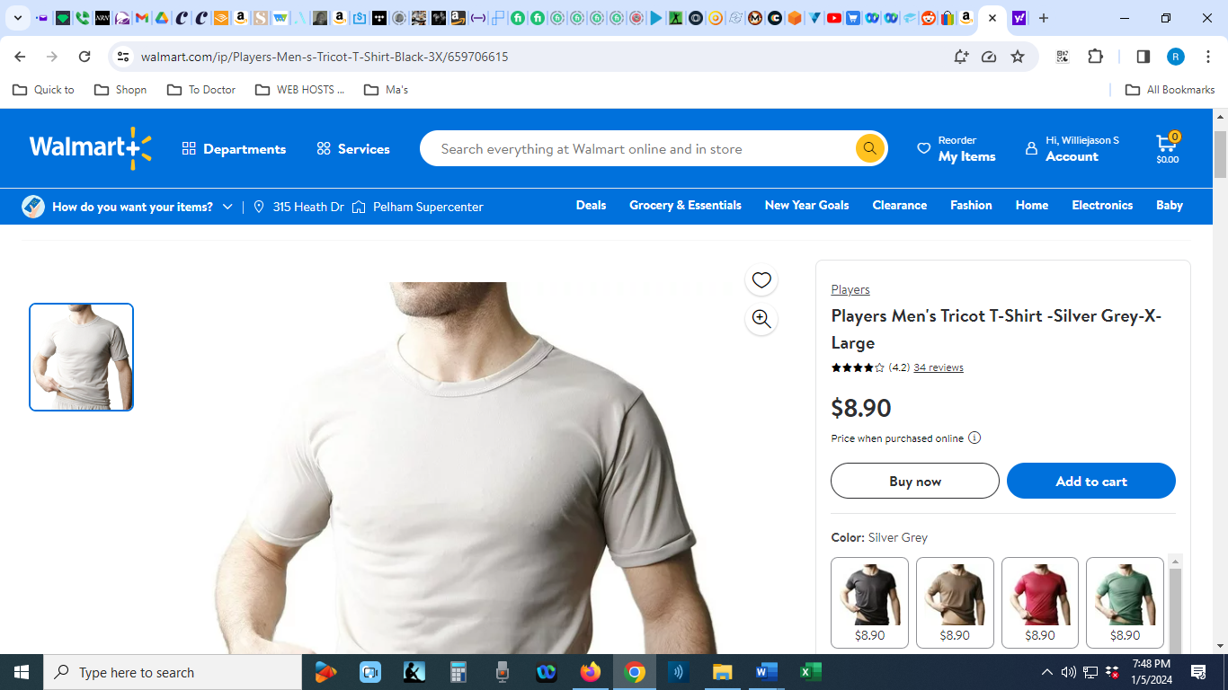

Link
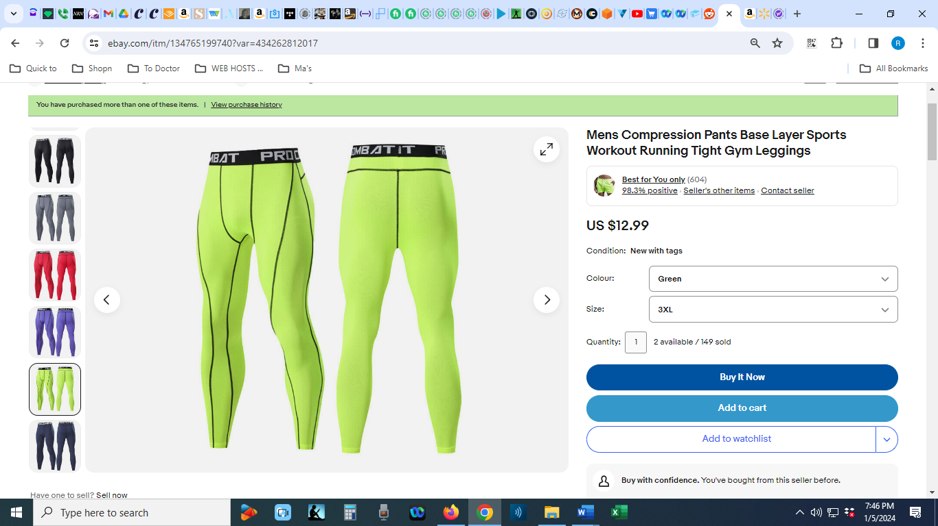
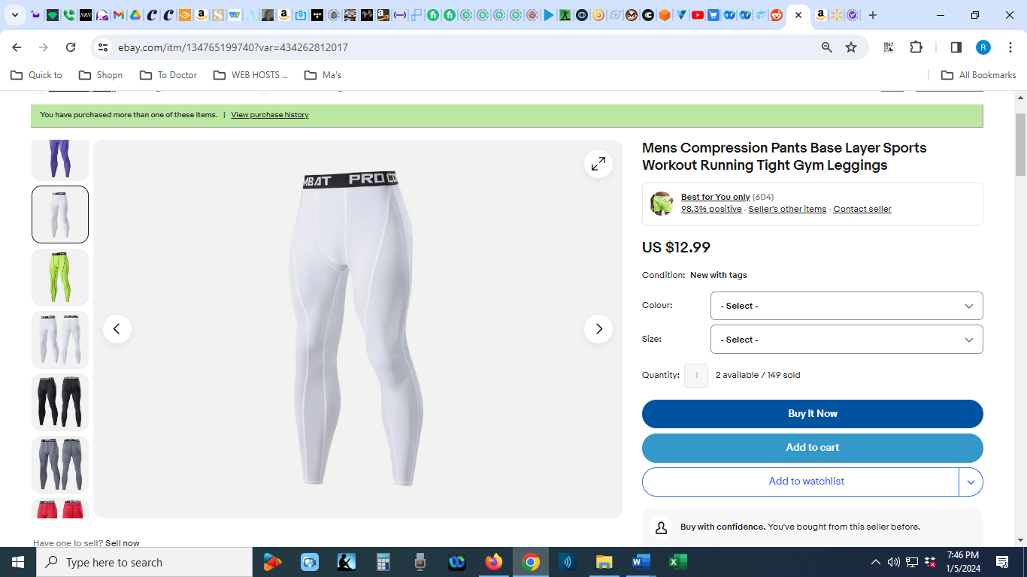

Link
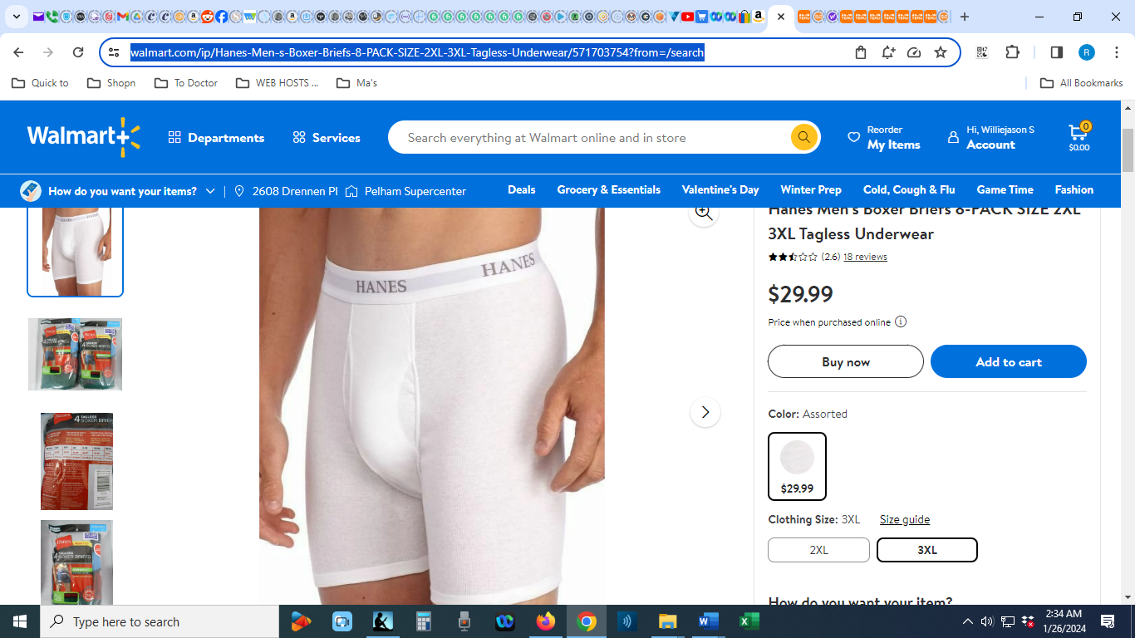

Link
