**LINK (**[**CLICK HERE**](https://www.ebay.com/itm/Boho-Funky-Ethnic-Unique-Black-Plastic-Metal-Grey-bead-necklace-screw-closure-9/182960658543?hash=item2a994e186f:g:Sv4AAOSwVKRaHY6P)**)**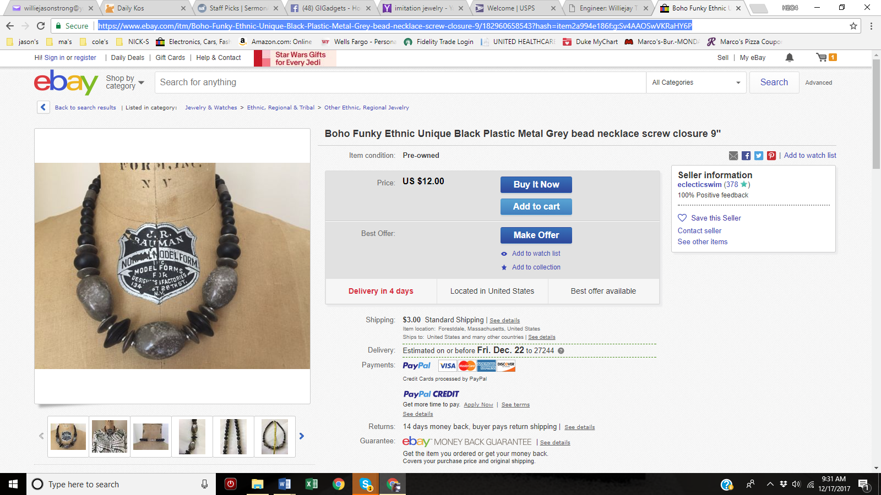

**LINK (**[**CLICK HERE**](https://www.etsy.com/listing/449597382/ribbon-statement-necklace-yellow-chunky?ga_order=most_relevant&ga_search_type=all&ga_view_type=gallery&ga_search_query=chunky%20necklace&ref=sr_gallery_38)**)**

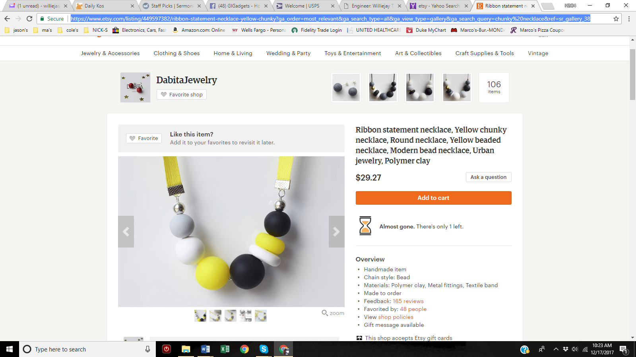

**LINK (**[**CLICK HERE**](https://www.etsy.com/listing/468608662/gray-statement-necklace-black-and-white?ref=shop_home_feat_1&pro=1)**)**

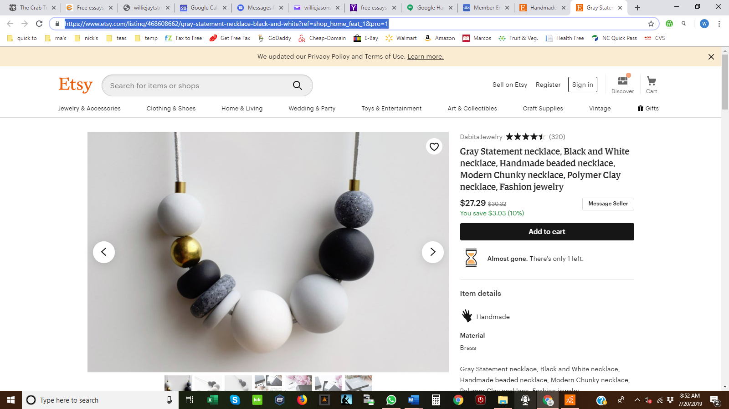

**LINK (**[**CLICK HERE**](https://www.etsy.com/listing/640866818/gray-statement-necklace-black-and-white?ref=shop_home_active_5&pro=1)**)**

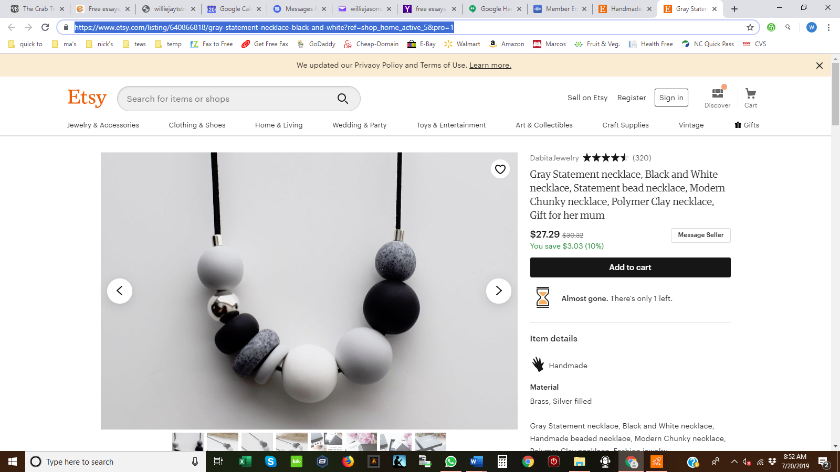

**LINK (**[**CLICK HERE**](https://www.etsy.com/listing/580728672/chunky-double-strand-statement-necklace?ref=shop_home_active_94)**)**

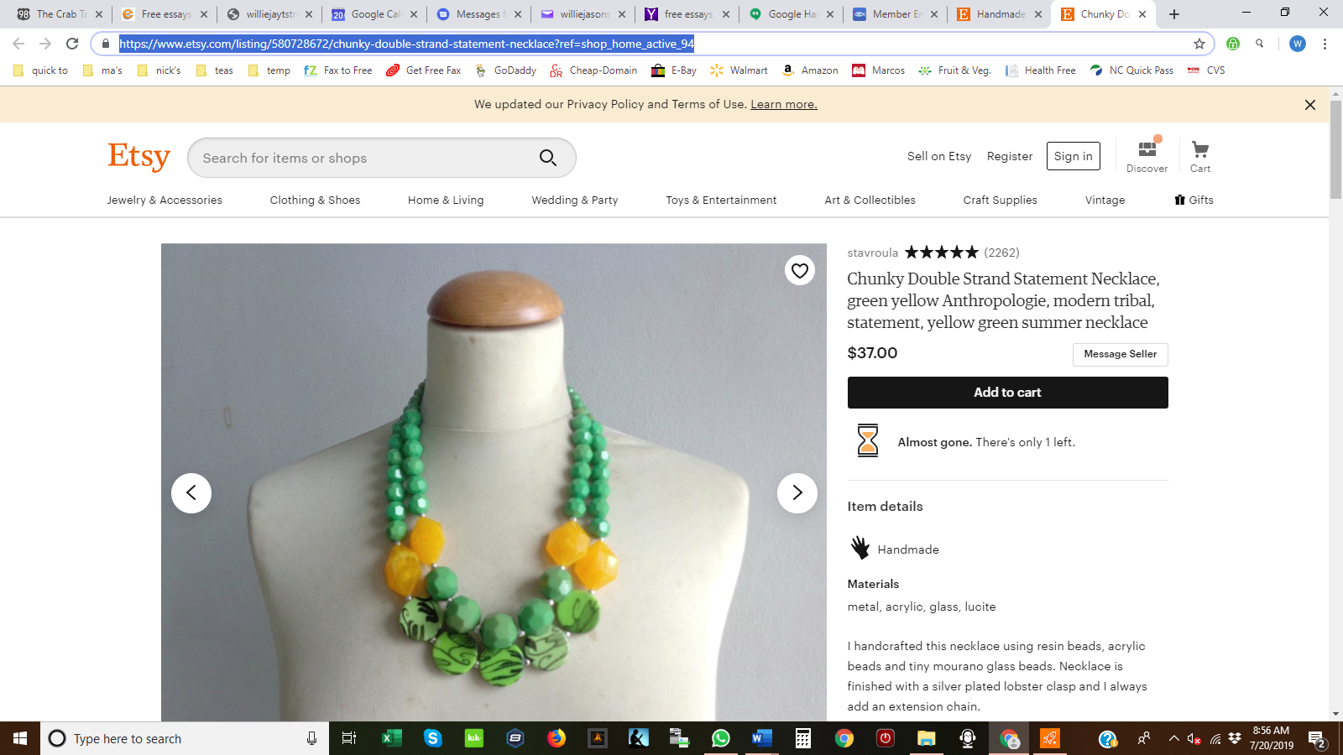

**LINK (**[**CLICK HERE**](https://www.etsy.com/listing/619055447/yellow-tassel-statement-necklace-longer?ref=shop_home_active_98)**)**

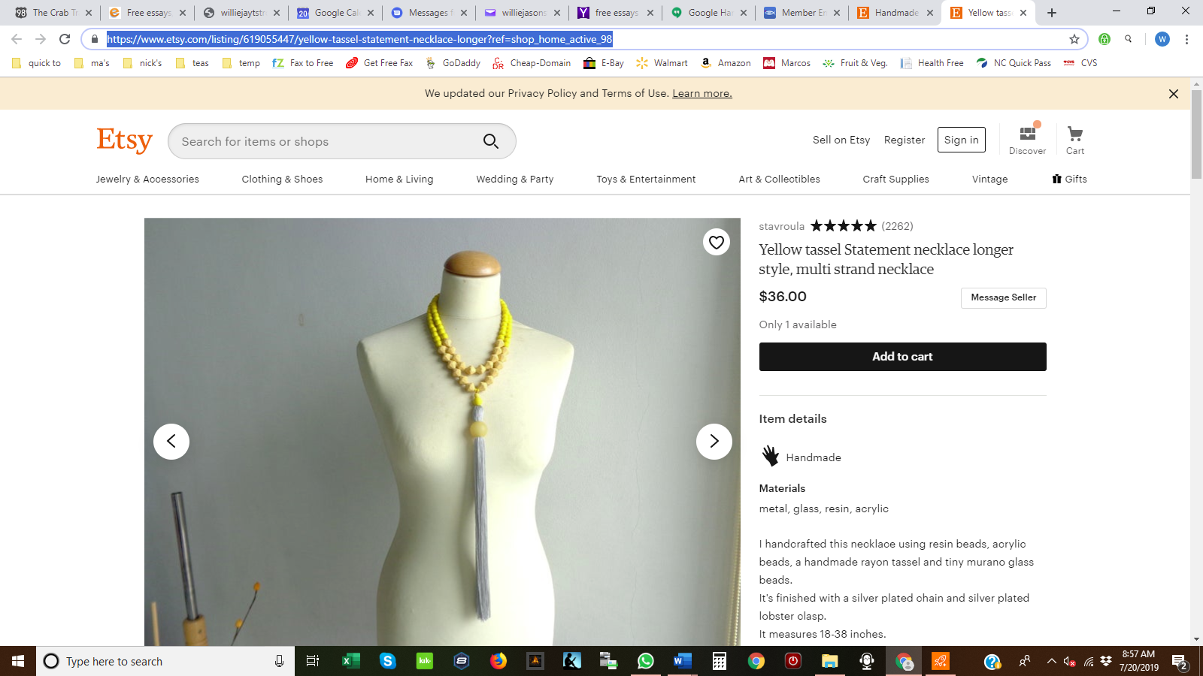

**LINK (**[**CLICK HERE**](https://www.etsy.com/listing/237518066/white-wedding-necklace-statement?ref=shop_home_active_104)**)**

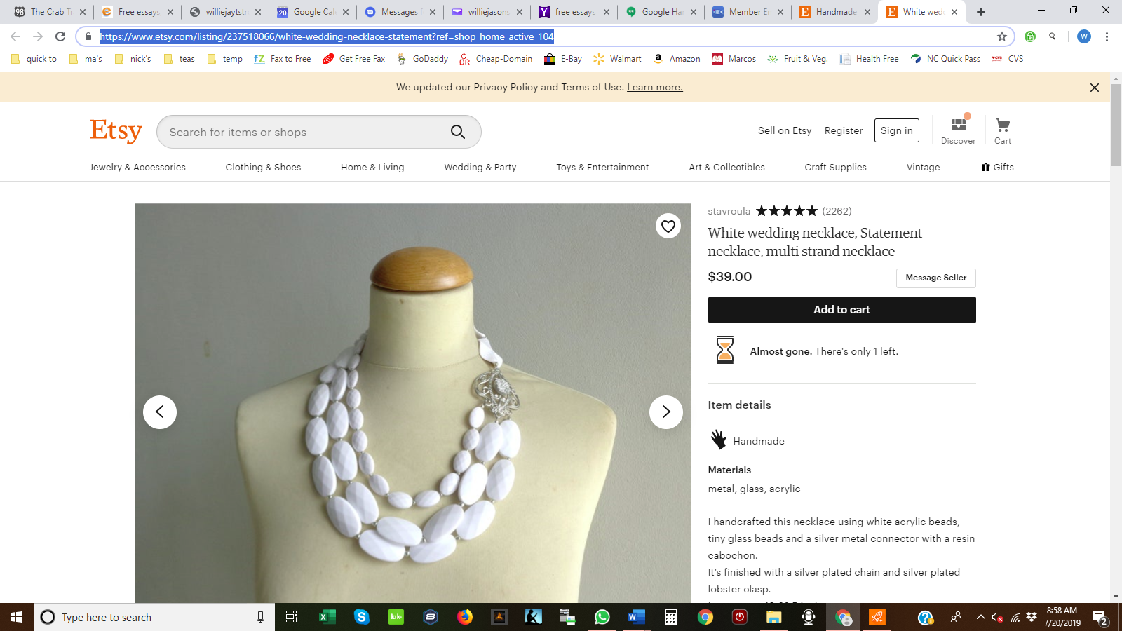

**LINK (**[**CLICK HERE**](https://www.etsy.com/listing/630441676/pearl-gold-statement-necklace-long-pearl?ref=shop_home_active_182)**)**

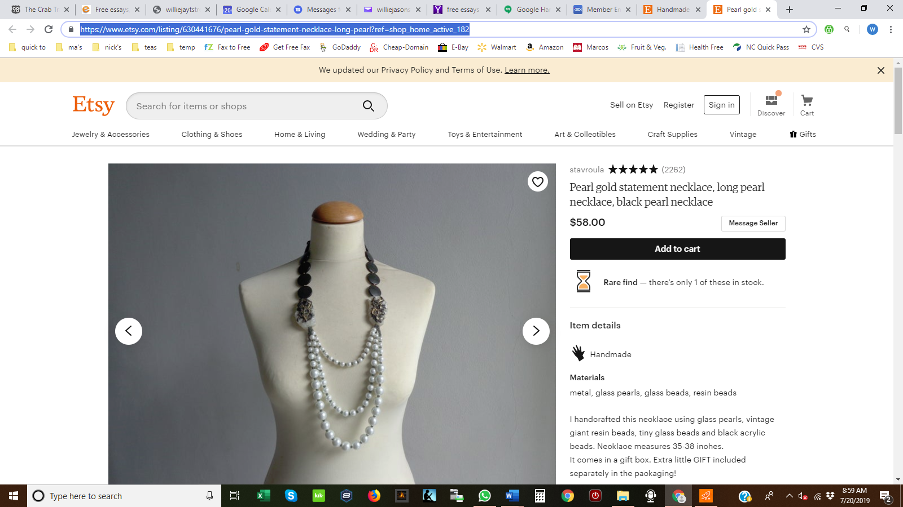

**LINK (**[**CLICK HERE**](https://www.etsy.com/listing/195342420/orange-yellow-flower-statement-colorful?ref=shop_home_active_432)**)**

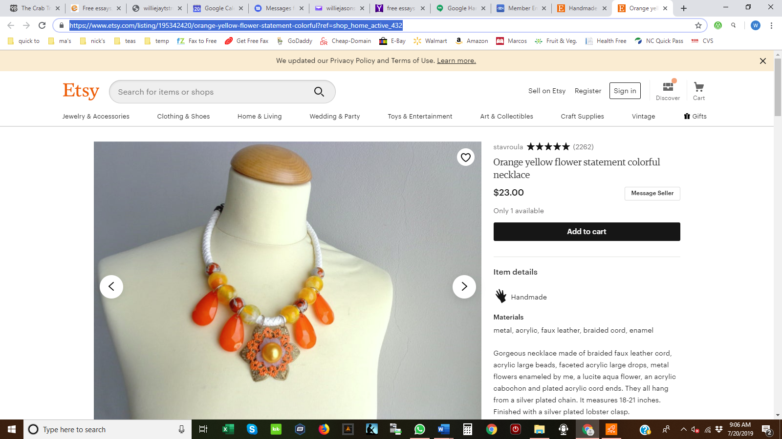

**LINK (**[**CLICK HERE**](https://www.etsy.com/listing/536661759/african-style-recycle-fabric-necklace?ga_order=most_relevant&ga_search_type=all&ga_view_type=gallery&ga_search_query=ethnic%20necklaces%20for%20women&ref=sr_gallery_28)**)**

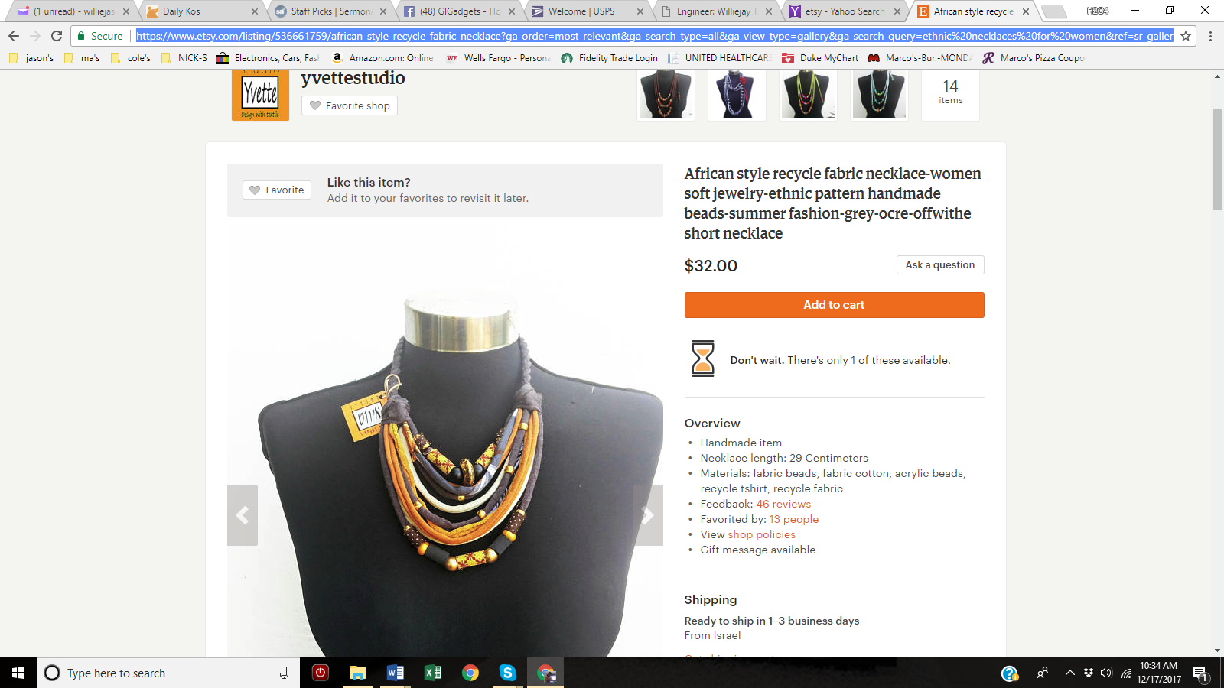

**LINK (**[**CLICK HERE**](https://www.etsy.com/listing/206396052/necklace-huge-vintage-folk-ethnic-from?ga_order=most_relevant&ga_search_type=all&ga_view_type=gallery&ga_search_query=ethnic%20necklaces%20for%20women&ref=sr_gallery_29)**)**

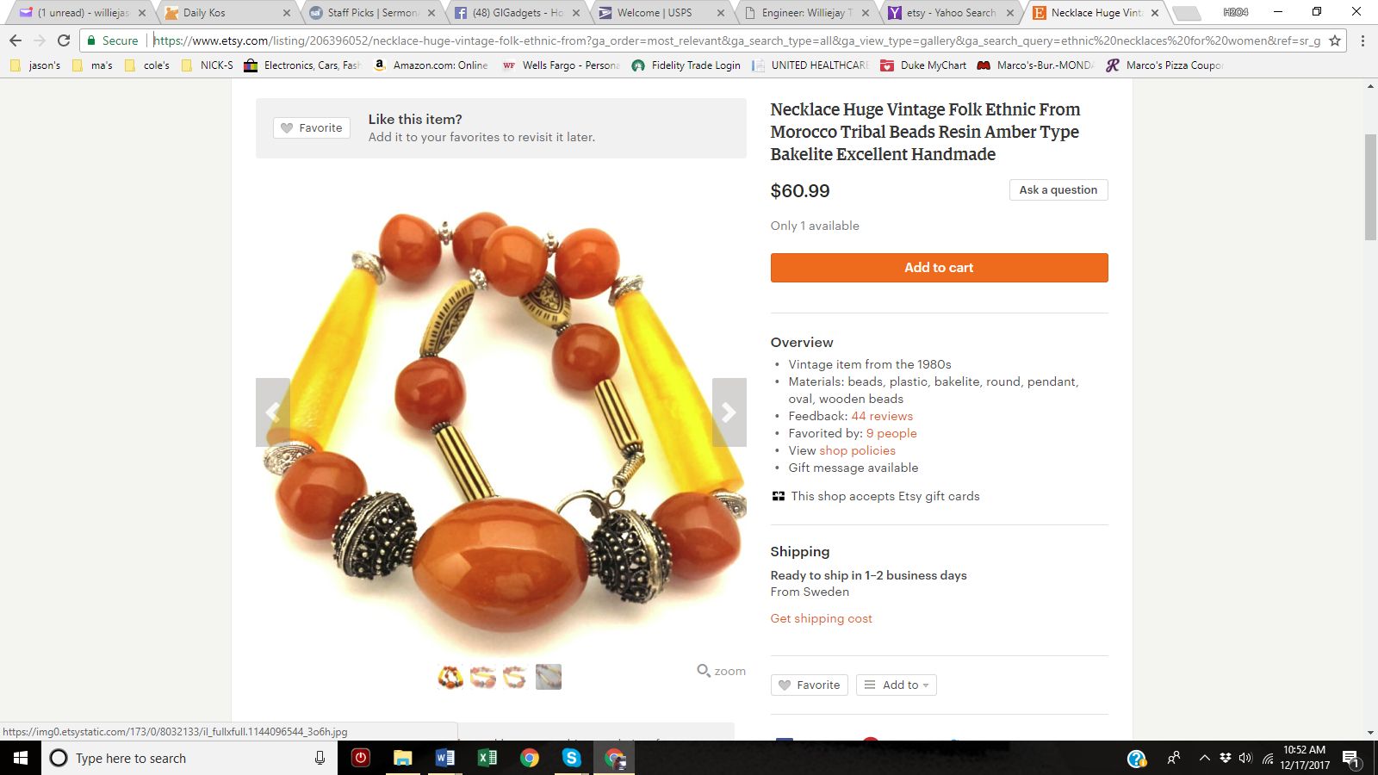

**LINK (**[**CLICK HERE**](https://www.etsy.com/listing/178367961/vintage-necklace-amber-morocco-pressed?ga_order=most_relevant&ga_search_type=all&ga_view_type=gallery&ga_search_query=ethnic%20necklaces%20for%20women&ref=sr_gallery_24)**)**

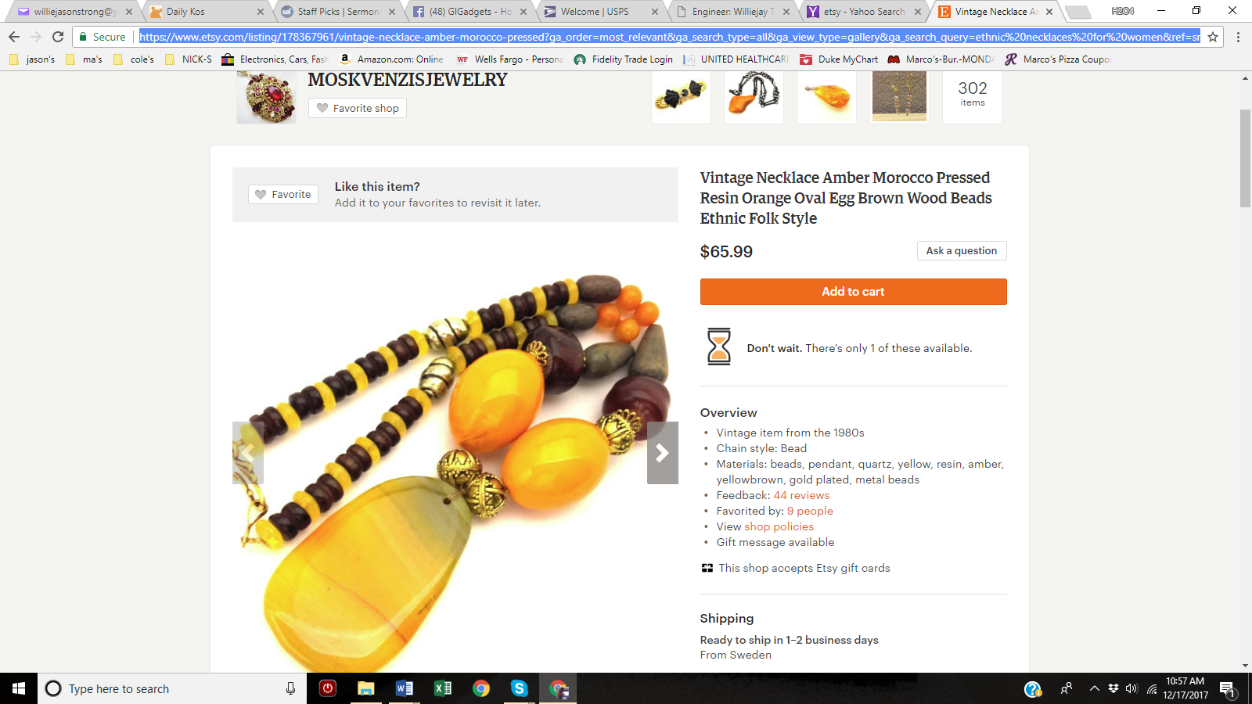

**LINK (**[**CLICK HERE**](https://www.etsy.com/listing/543577888/bright-statement-necklace-african-rope?ga_order=most_relevant&ga_search_type=all&ga_view_type=gallery&ga_search_query=ethnic%20necklaces%20for%20women&ref=sr_gallery_43)**)**

