NOTE: These are TO BE WORN WITH BLACK, WHITE, OR DARK GREY LEGGINGS.
LINK (CLICK HERE)
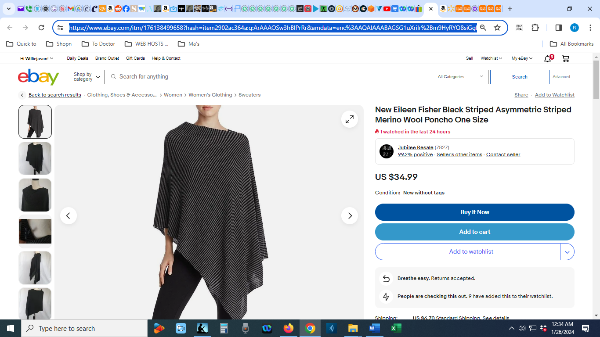

LINK (CLICK HERE)
