ALL-YEAR COOL WEAR
PURPOSE: To look cool and have great spiritual meaning at a low cost. Recommended have: 5 outerwear shirts, 2 pair of break-away pants (found on eBay), one pair of shoes and three shorts. Note: You would be able to find the cheapest clothes on www.Temu.com; and they do have so much plus sizes.

MEANINGS
TOPS
King Shirts means we are kings, not slaves.

Baseball/Soccer Jersey = we promote Spiritual non-biased, non-violent sports;

NY Yankees baseball team means we do not believe in Racism and are Communication Outspoken (NY, NY USA is known for freedom of speech).

Mexican Jerseys mean we are for Mexicans too.

Black Sheep Shirt = We Spiritual People are the “black sheep” of the world;

We have the “power” of Green Lantern;
Cool looking Lime Green shirts mean we have God’s SPECIAL energy. And for green sun solar energy meditation.

Cool Looking Yellow Shirts mean we are bright.
And for yellow sun solar energy healing that God sometimes give.

ASSESSORIES ...
#1 Wrist band = To look even cooler, means we are the winners by far, #1 and that we are with God, #1.

Baseball hat worn to the right = To look even cooler.

Skull cap to look cool.

Lion Shirts, Chain and Ring
It stands for promoting the tribe of Judah, blacks; represents the strength of God. It means we are:
Fearless
Wise
Quick
Ferocious

High Leg Socks = To look cool

Arm ... Compression to look cool.

Tennis Shoes = We are young and lively, athletic no matter what our ages are.

OUTTERWEAR SHIRTS
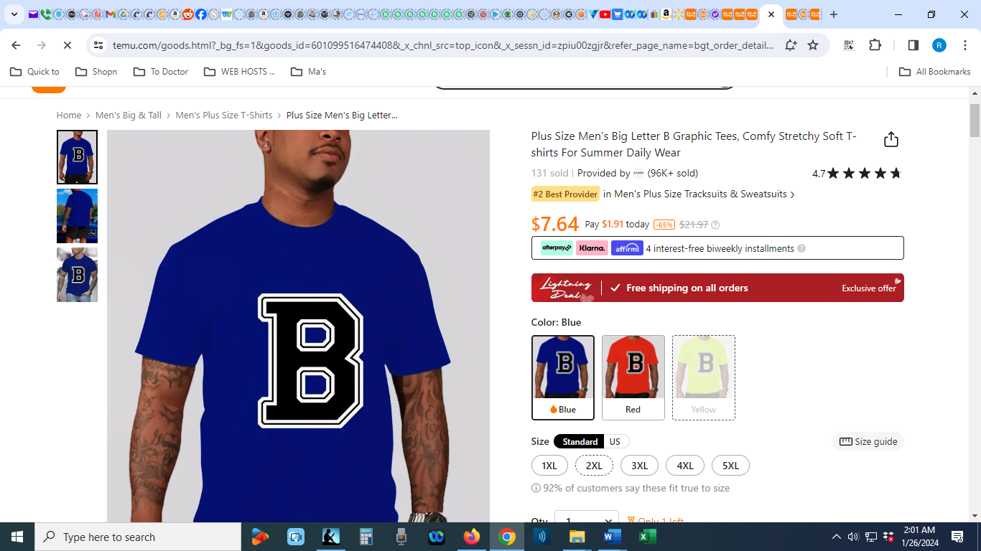
Link

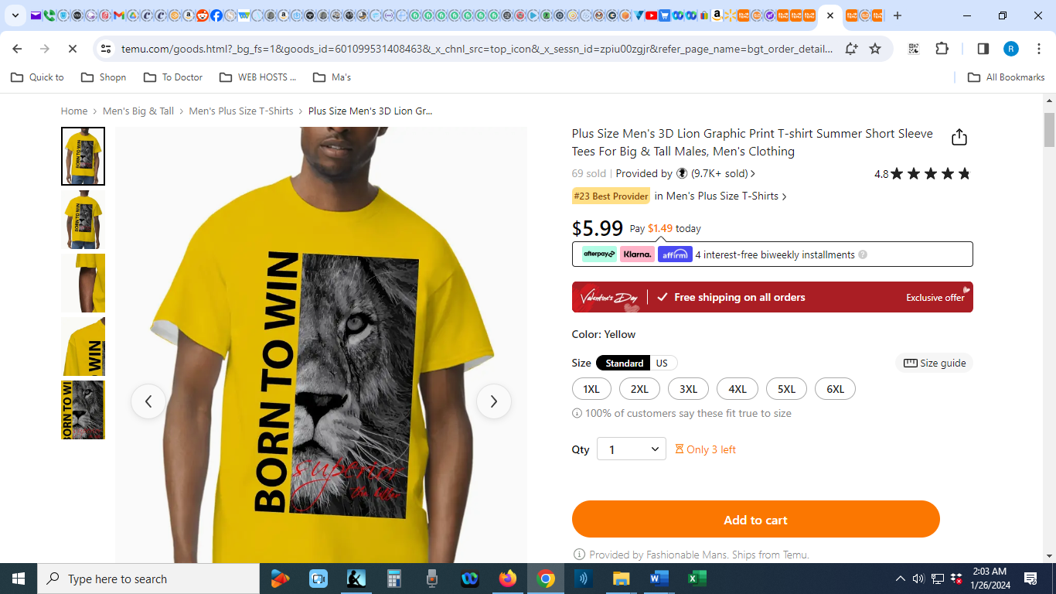
Link

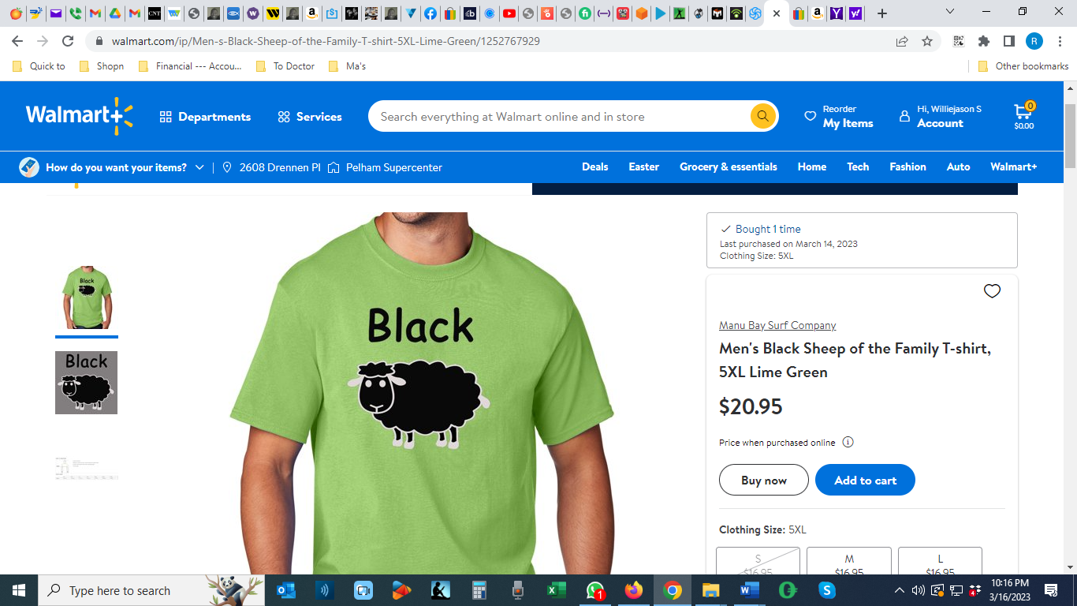
Link

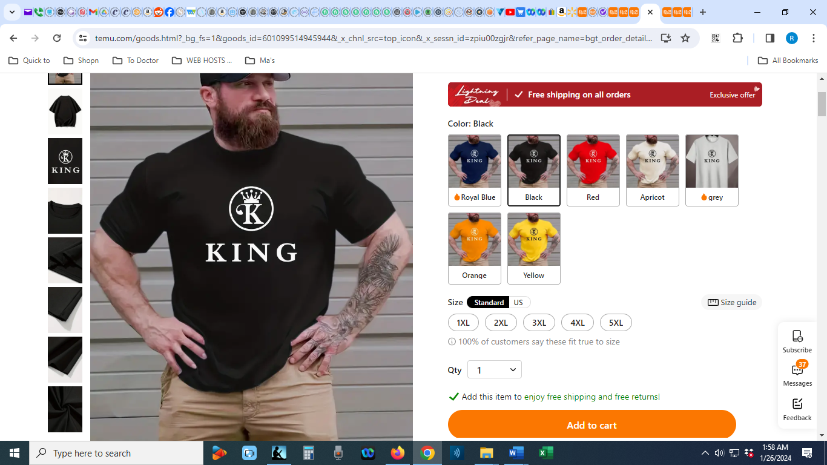
Link

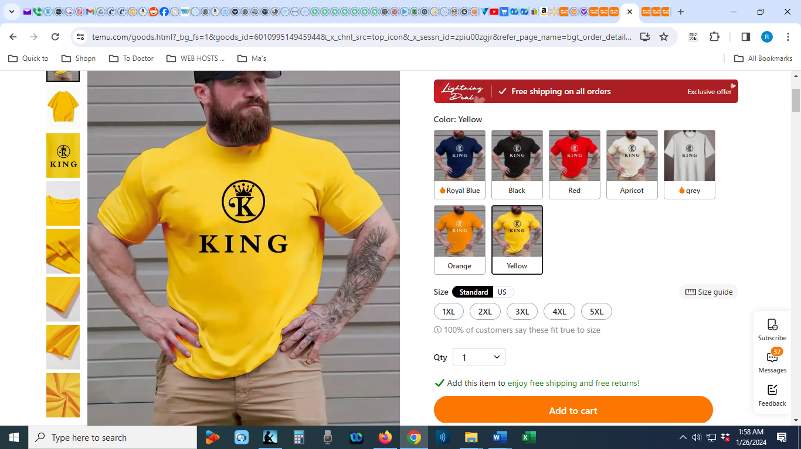
Link
SHORTS
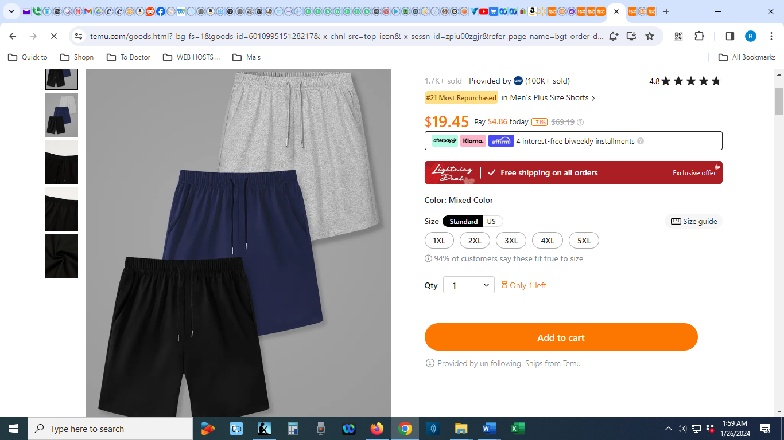
Link

PANTS
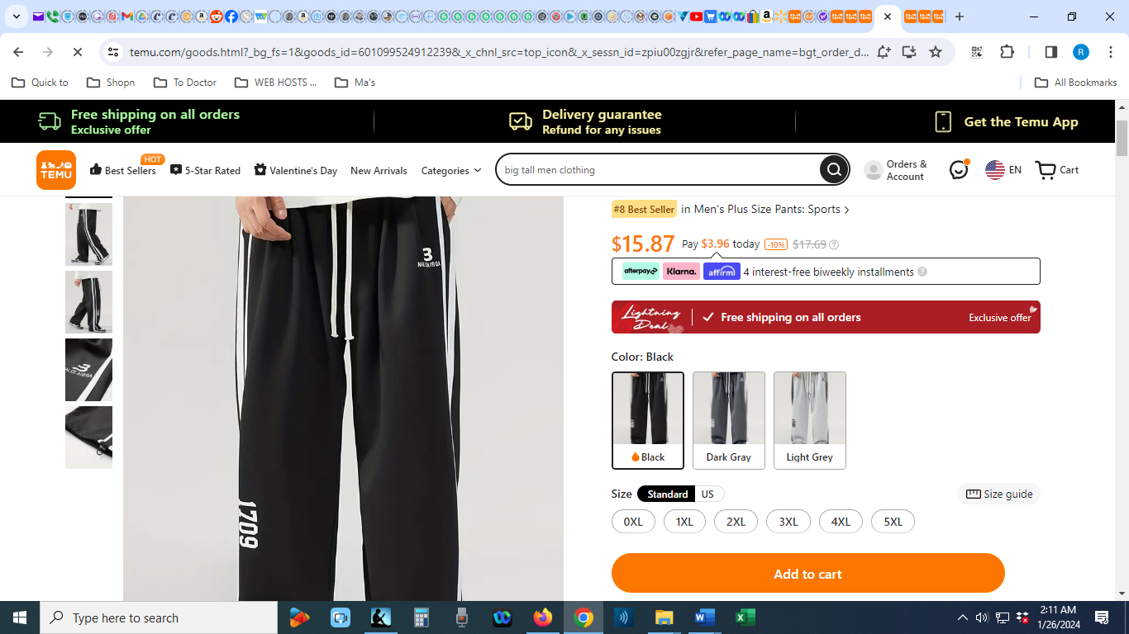
Link

ASSESSORIES
BASEBALLWRIST BAND  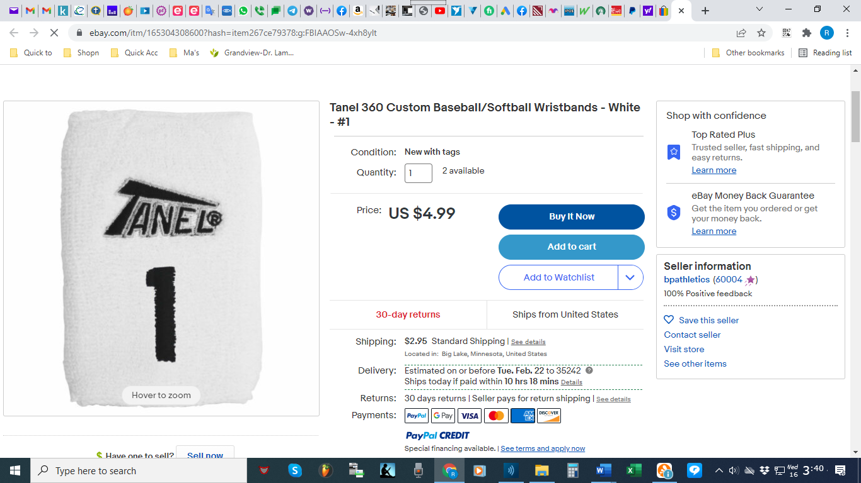 | eBay | Link
LION OF THE LORD PROTECTION NECKLACE  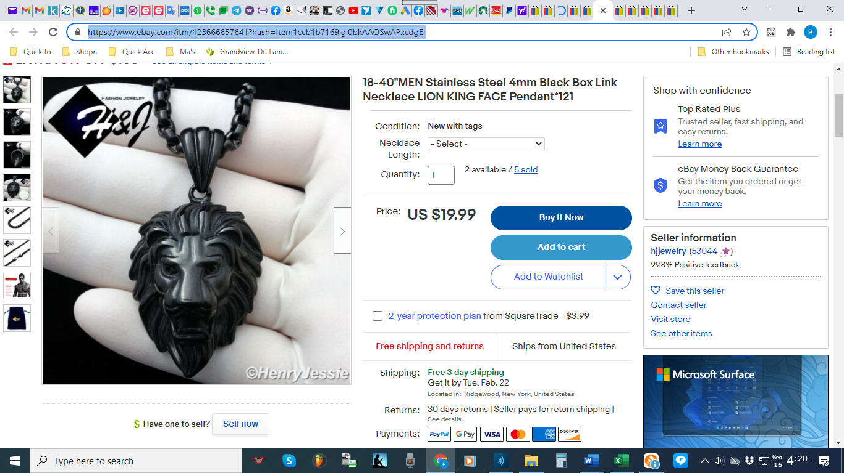 | eBay | Link
LION OF THE LORD RING  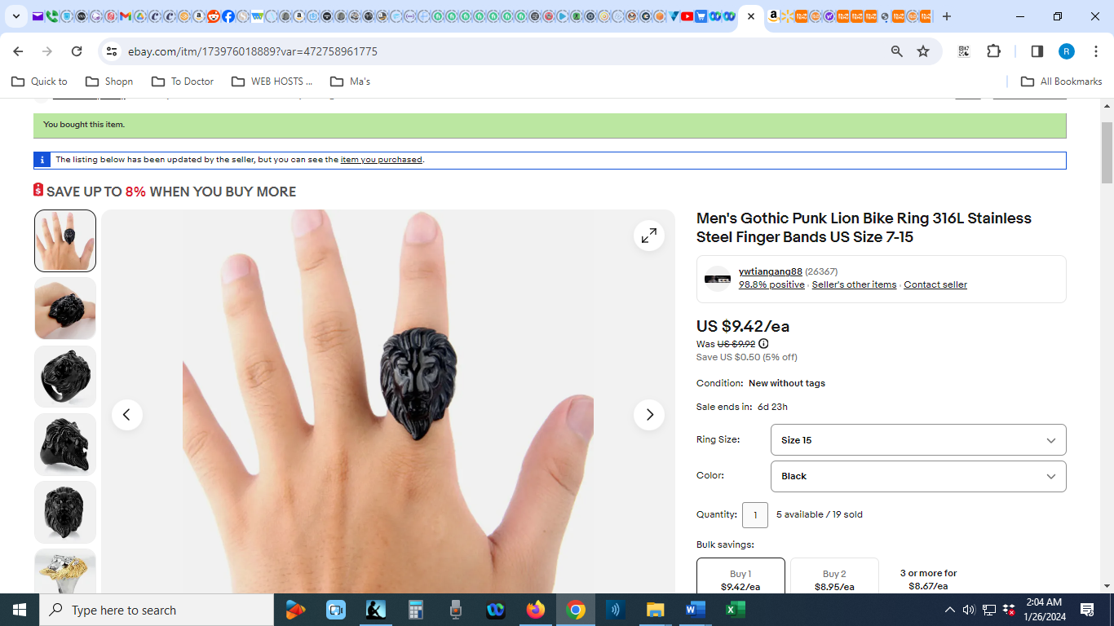 | eBay | Link
BASEBALL/SOCCER SOCKS  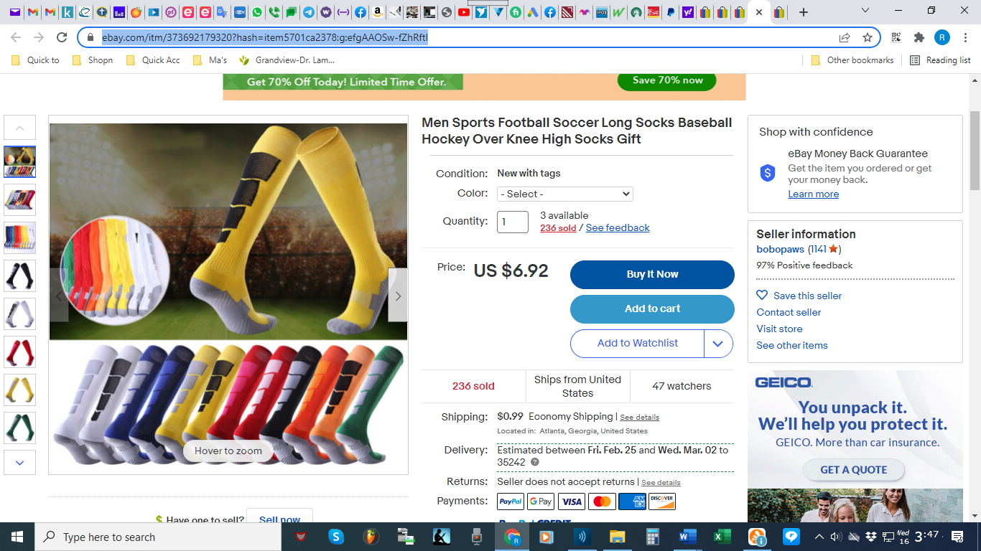 | eBay | Link
ARM COMPRESSION  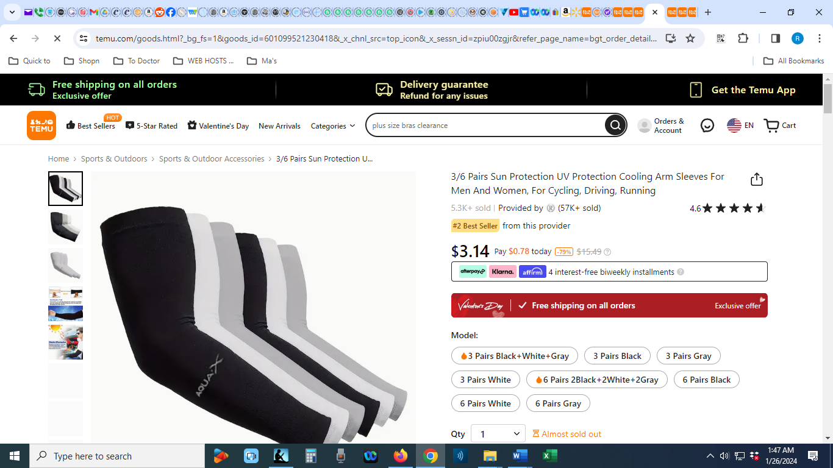 | Temu | Link
SLOUCH BEANIC (BLACK OR WHITE)  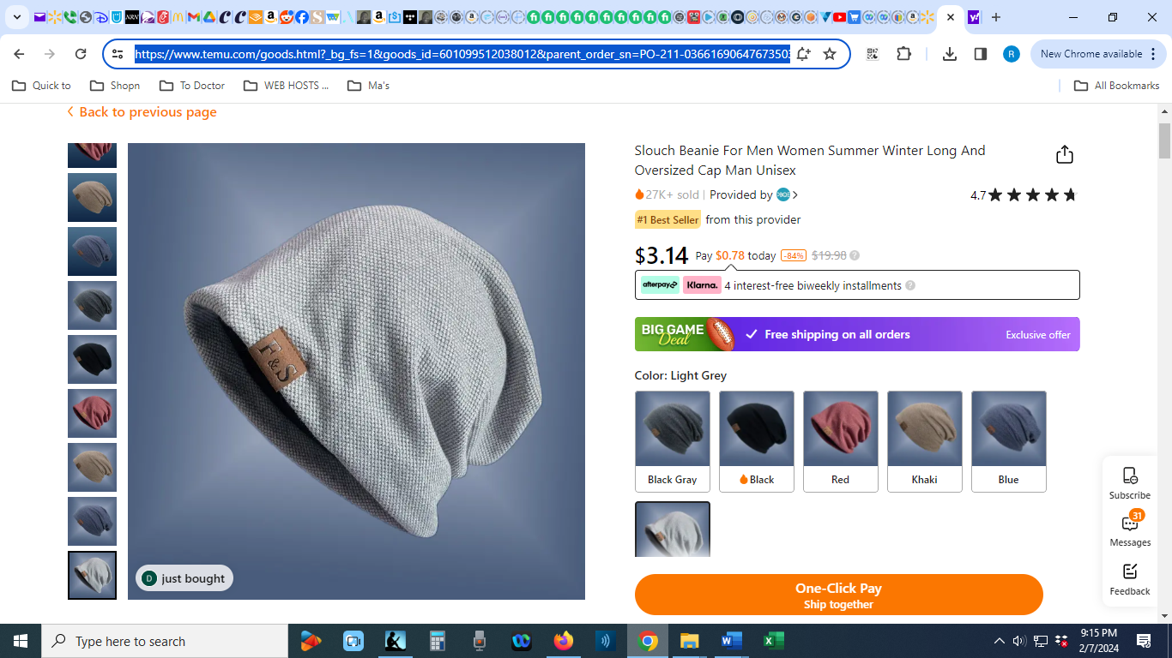 | Temu | Link
BASEBALL HAT (GREEN, NY YANKIES BLACK AND WHITE, OR WHITE)  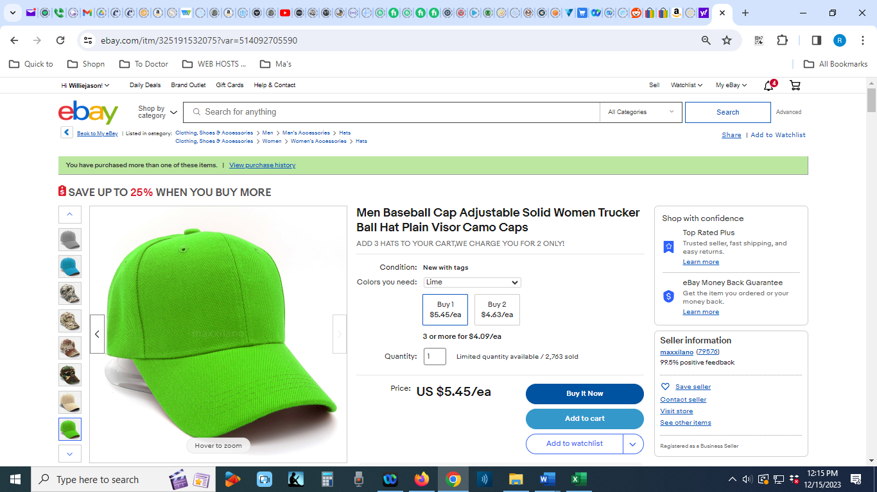 | eBay | Link

SHOES
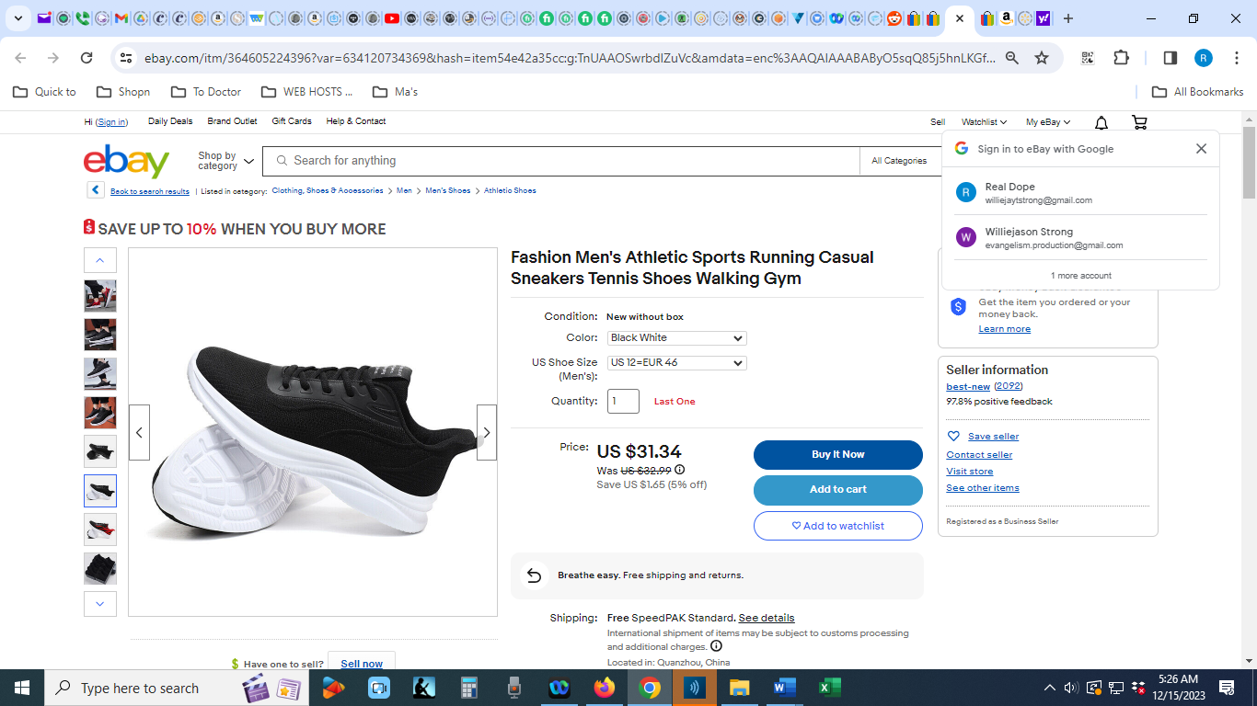
Link

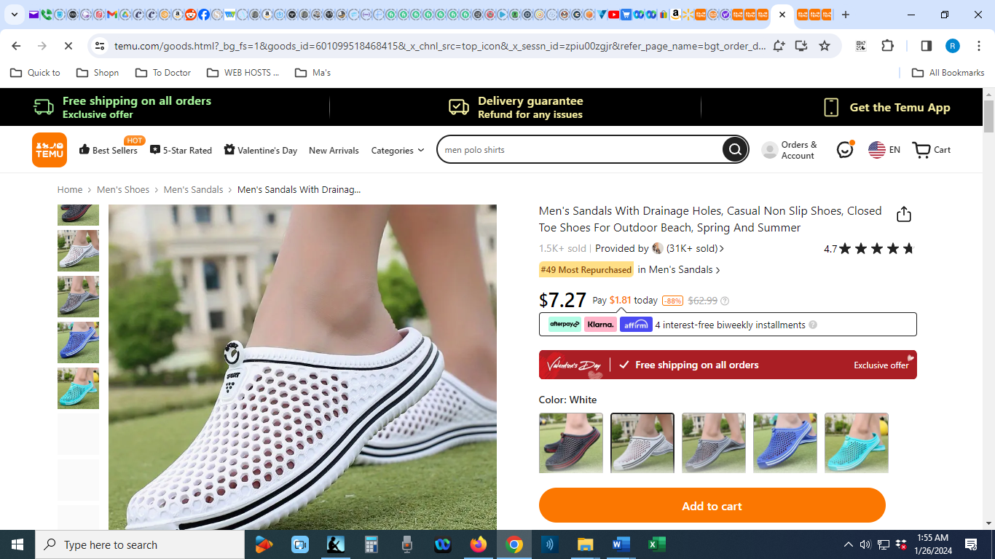
Link

JACKET
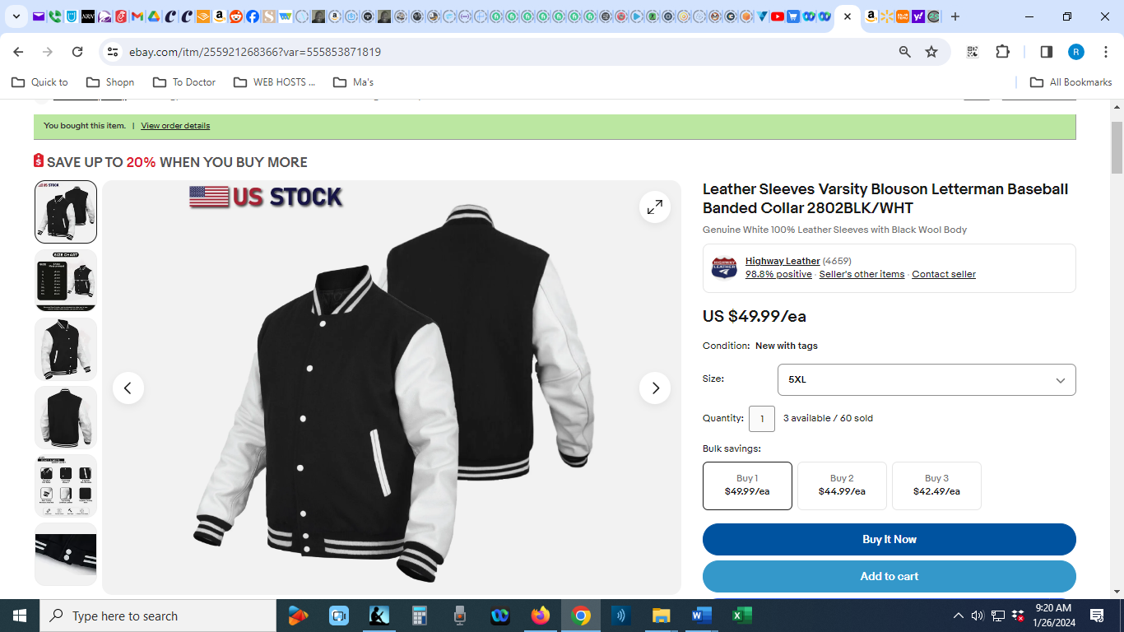
Link

